THE TOLL SUPERVISION PRODUCT
CLIENT AND SERVER CONFIGURATION
Project name : | Customer - Project (Projet in properties)
Project Redo : | -
Reference : | CSSI-ISC / 211 - 1 /XX/ XX/ 5 /00 xxx | Version : |  | Date : | xx/xx/2005
Verified by : |  | Visa : |  | Date :
Approved by : |  | Visa : |  | Date :
Qualification:
Author : | CSSI
Origin : | DA ISC / Intelligent Transport Systems
Distribution list :  Company | CSSI

history evolution

version | Date | Modification | Author
1A | 20/02/06 | First revision | CSSI
Table of content

Page

1. General 8
1.1. Introduction 8
2. Toll supervision SERVER CONFIGURATION (SRVPVSVC) 9
2.1. Registry settings 9
2.1.1. Communication Settings 9
2.1.1.1. Common Acom settings 9
2.1.1.2. RouteSvc Communication Settings 11
2.1.1.3. PV Communication Settings 12
2.1.1.4. CmdSvc Communication Settings 13
2.1.2. Plaza Configuration Settings 14
2.1.2.1. INI Files Settings 14
2.1.2.2. Database Settings 14
2.1.3. Message Settings 16
2.1.3.1. General Settings 16
2.1.3.2. Class information 17
2.1.3.3. Payment Information 19
2.1.3.4. Alarm Information 19
2.1.3.5. Lane Information 20
2.1.4. Debug 21
2.1.4.1. PvHookDaysOfRetention 21
2.1.4.2. PvHookEnable 21
2.1.4.3. PvHookFilesPath 21
2.2. PLAZA DESCRIPTION 22
2.2.1. Database Diagram 23
2.2.2. GEN_DEF (.INI) 24
2.2.3. T_ANOMALY (.INI) 24
2.2.4. T_CLASS (.INI) 24
2.2.5. T_COMMAND (.INI) 24
2.2.6. T_CONCERN (.INI) 25
2.2.7. T_CURRENCY (.INI) 25
2.2.8. T_DETAIL_PAYMENT_TYPE (.INI) 25
2.2.9. T_EVENT (.INI) 25
2.2.10. T_EVENT_SUB_TYPE (.INI) 26
2.2.11. T_LANE (.INI) 26
2.2.12. T_LANE_ATTACH_TO (.INI) 27
2.2.13. T_LANE_EQUIPMENT (.INI) 27
2.2.14. T_LANE_EQUIPMENT_TYPE (.INI) 27
2.2.15. T_MENU (.INI) 27
2.2.16. T_PAYMENT_TYPE (.INI) 28
2.2.17. T_PLAZA (.INI) 28
2.2.18. T_PROFILE (.INI) 28
2.2.19. T_PROFILE_USE_COMMAND (.INI) 28
2.2.20. T_PROFILE_USE_MENU (.INI) 28
2.2.21. T_RTO_LANE_COUNTER (.INI) 29
2.2.22. T_SESSION_PROFILE_STATION (.INI) 29
2.2.23. T_STAFF (.INI) 29
2.2.24. T_TRANSLATE (.INI) 30
3. Toll supervision CLIENT CONFIGURATION (PV) 31
3.1. AVAILABLE PROPERTIES 31
3.2. APPLICATION OBJECTS 36
3.2.1. About 36
3.2.2. Adetails 37
3.2.3. Alarms 38
3.2.4. Album 39
3.2.5. Authentication 40
3.2.6. BControle 41
3.2.7. Beeps 42
3.2.8. Bemptying 43
3.2.9. Bfilling 44
3.2.10. Bprinting 45
3.2.11. Bowls 46
3.2.12. Cdetails 47
3.2.13. Commands 48
3.2.14. Communicate 49
3.2.15. Connect 50
3.2.16. Counting 51
3.2.17. Disconnect 52
3.2.18. Disk 53
3.2.19. Icon 54
3.2.20. Lane 55
3.2.21. Limits 56
3.2.22. Menu 57
3.2.23. MsgE 58
3.2.24. MsgI 59
3.2.25. MsgQ 60
3.2.26. Options 62
3.2.27. Plaza 68
3.2.28. Prints 71
3.2.29. Tdetails 72
3.2.30. Transactions 73
3.2.31. Vaults 74
3.2.32. Vdetails 75
3.2.33. Zalarms 76
3.2.34. Zbowls 77
3.2.35. Zcommands 78
3.2.36. Zdisk 79
3.2.37. Zip 80
3.2.38. Zlane 81
3.2.39. Ztransactions 82
3.2.40. Zvaults 83
3.3. SETTINGS FILEs 84
3.3.1. RESOURCE 85
3.3.2. DICO 85
3.3.3. COMMAND 86
3.3.4. DISPLAY 90
3.3.5. ZONE 91
3.3.6. TYPE 92
3.3.7. EQUIPMENT 93
3.3.8. ERROR 95
3.3.9. FUNCTION 95
3.3.10. PLAZA 95
3.3.11. PRINT 96
3.3.12. USER 96
3.4. SPECIFIC SETTINGS 97
3.4.1. Event Icons 97
3.4.2. Transaction anomaly Icons 97
3.4.3. Transaction Icons 98
3.4.4. Events level colour 98
3.4.5. Message Box Text 99

General

Introduction
The aim of this document is to make easy the configuration of the Toll Supervision Terminal Product by a detailed description of each configuration file and registry key.

The Toll Supervision Product is composed of two applications :
- The Toll Supervision Server : SrvPvSvc.exe (service)
- The Toll Supervision Client : PV.exe (HMI)

The concerned versions for the SrvPSvc : 2.0.4.8 and 2.1.1
The concerned version for the PV : 4.4.1

Toll supervision SERVER CONFIGURATION (SRVPVSVC)
The configuration of the server is composed of two parts :
- The general settings of the server located in the registry.
- The description of the plaza (name, number of lanes, lane types, equipment, devices,…) located in database (ORACLE) or in text files (INI files).

Registry settings
The settings are described under the following key :
HKEY_LOCAL_MACHINE\SYSTEM\CurrentControlSet\Services\SrvPvSvc\Parameters
Here after is described the meaning of each registry value. The values are given by group of functionalities.

Communication Settings
The communication tasks are provided by the CSR_ACOM tool. Acom parameters are defined for the RouteSvc, PV and CmdSvc interface communication tasks.

Common Acom settings
The following values are common for the communication with RouteSvc, the PV and CmdSvc.

BufferSize
- Name : BufferSize
- Type : REG_DWORD
- Default Value : 32000
- Meaning : Size of the internal buffer for the communication management.

LifeTime
- Name : LifeTime
- Type : REG_DWORD
- Default Value : 5000
- Meaning : Delay between two life messages (Acom is set up to use the “Life Protocol”).

MaxLife
- Name : MaxLife
- Type : REG_DWORD
- Default Value : 3
- Meaning : Max number of life messages sent without response before considering the connection is out.

MaxMsgSize
- Name : MaxMsgSize
- Type : REG_DWORD
- Default Value : 16384
- Meaning : Max size of a message. If a message exceed this size, it will be truncated.

QueueSize
- Name : QueueSize
- Type : REG_DWORD
- Default Value : 256
- Meaning : Max number of messages in the message queue.

ReconnectTime
- Name : ReconnectTime
- Type : REG_DWORD
- Default Value : 1000
- Meaning : Delay between two connection tries after a disconnection.

RouteSvc Communication Settings

NbComServer
- Name : NbComServer
- Type : REG_DWORD
- Default Value : 1
- Meaning : Number of machines (to connect with) where an instance of RouteSvc is running (Ref : ComServer%dMachineName).
Note : The number of simultaneous identified connections (like named pipes) is limited by windows.

ComServer%dMachineName
- Name : ComServer%dMachineName
- Type : REG_SZ
- Default Value : .
- Meaning : name of the machine for the connection with RouteSvc by named pipe.
ComServer1MachineName : Name of the machine where an instance of RouteSvc is running.
ComServer2MachineName : Name of the machine where an instance of RouteSvc is located
…
Note : Depends on the value of the NbComServer key.

Com_Failure_Message
- Name : Com_Failure_Message
- Type : REG_SZ
- Default Value : COM SERVER COMMUNICATION FAILURE
Meaning : Message displayed at the PV in case of communication failure between SrvPvSvc and RouteSvc.

Workers
- Name : Workers
- Type : REG_DWORD
- Default Value : 3
- Meaning : Acom setting. Number of workers for the management of the connection with RouteSvc.
Note : In case of communication with TCP, the number of workers must be superior to 1.

PV Communication Settings

MaxPVCnx
- Name : MaxPVCnx
- Type : REG_DWORD
- Default Value : 10
- Meaning : Max number of simultaneous connections of PV.
Note : The number of simultaneous identified connections (like named pipes) is limited by windows.

Com_Reload_Server
- Name : Com_Reload_Server
- Type : REG_SZ
- Default Value : SERVER SHUTDOWN IN 10 SECONDS!
- Meaning : Message displayed at the PV in case of reload of the SvrPvSvc service
Note : Reload is a CmdSvc Command.

SrvPvWorkers
- Name : SrvPVWorkers
- Type : REG_DWORD
- Default Value : 3
- Meaning : Acom setting. Number of workers for the management of the connection with the PV.
Note : In case of communication with TCP, the number of workers must be superior to 1.

CmdSvc Communication Settings

CmdSvcEnabled
- Name : CmdSvcEnabled
- Type : REG_DWORD
- Default Value : 1
- Meaning : This value sets whether the connection of a CmdSvc Interface is allowed.
If Set to 0 : not allowed
If Set to 1 : allowed by using a named pipe : \\.\pipe\SrvPVSvc\CMD
Else : allowed by TCP : the value of the key represents the TCP port number

MaxCmdCnx
- Name : MaxCmdCnx
- Type : REG_DWORD
- Default Value : 1
- Meaning : Max number of simultaneous connections of CmdSvc interfaces
Note : The number of simultaneous identified connections (like named pipes) is limited by windows.

SrvCmdWorkers
- Name : SrvCmdWorkers
- Type : REG_DWORD
- Default Value : 1
- Meaning : Number of workers for the management of the connection with the CmdSvc interface.
Note : In case of communication with TCP, the number of workers must be superior to 1.

Plaza Configuration Settings
The Plaza configuration can be defined in INI files or in Oracle database.

INI Files Settings

INI_Files_Path
- Name : INI_Files_Path
- Type : REG_SZ
- Default Value : .
- Meaning : Path for the INI files directory
Note : Not used in case of configuration in database.

Database Settings

DB_Failure_Message
- Name : DB_Failure_Message
- Type : REG_SZ
- Default Value : DATABASE COMMUNICATION FAILURE
- Meaning : Message displayed at the PV in case of communication failure between SvcPvSvc and the database.
Note : Not used in case of configuration in INI files.

DbEncryptedPassword
- Name : DbEncryptedPassword
- Type : REG_DWORD
- Default Value : DATABASE COMMUNICATION FAILURE
- Meaning : Sets whether the user passwords are encrypted in the database (T_STAFF table) or in INI file (T_STAFF.INI).

DbEncryptionDll
- Name : DbEncryptionDll
- Type : REG_SZ
- Default Value : none
- Meaning : Path of the encryption dll to use to encrypt the passwords keyed in by the user (in order to compare it to the encrypted password stored in the database or in the ini files)
Note : Not used if DbEncryptedPassword sets to 0

DbInstance
- Name : DbInstance
- Type : REG_SZ
- Default Value : ENTER DATABASE NAME HERE!
- Meaning : Used for the connection to the Oracle Database : name of the client instance
Note : Not used in case of configuration in INI files.

DbPassword
- Name : DbPassword
- Type : REG_SZ
- Default Value : pvpwd
- Meaning : Used for the connection to the Oracle Database : password of the user
Note : Not used in case of configuration in INI files.

DbReconnectionDelay
- Name : DbPassword
- Type : REG_DWORD
- Default Value : 60000
- Meaning : In case of connection failure between SrvPvSvc and the database : Delay between two connection tries
Note : Not used in case of configuration in INI files.

DbUser
- Name : DbUser
- Type : REG_SZ
- Default Value : pvuser
- Meaning : Used for the connection to the Oracle Database : name of the user
Note : Not used in case of configuration in INI files.

PermanentDbConnection
- Name : PermanentDbConnection
- Type : REG_DWORD
- Default Value : 1
- Meaning : If set to 0 : the connection with the database is opened and closed at each access
If set to 1 : the connection with the database is permanent

Message Settings

General Settings

MsgId
- Name : MsgId
- Type : REG_DWORD
- Default Value : 120
- Meaning : ID of the messages sent by SrvPvSvc.

RealTimeUpdate
- Name : RealTimeUpdate
- Type : REG_DWORD
- Default Value : 1
- Meaning : Sets whether the PV is refreshed at each new message coming from the lanes (1) or if it is refreshed periodically (0).

RefreshPeriod
- Name : RefreshPeriod
- Type : REG_DWORD
- Default Value : -1
- Meaning : Refresh period of the PV.
Note : Not used if RealTimeUpdate is set to 1.

Class information

ClassKeyinPosition
- Name : ClassKeyInPosition
- Type : REG_DWORD
- Default Value : 0
- Meaning : The “Complementary Transaction Information” message (sent by the Lane to SrvPvSvc at each “Transaction Class” tabulation from the collector) contains the Class Keyin information. The “Lane State” message ( between SrvPvSvc and PV) contains a list of 4 class information. This value sets the position in this list where to store the Class Keyin information.
Note : If sets to 0, this information will not be stored.

ClassOnTheFly1Position
- Name : ClassOnTheFly1Position
- Type : REG_DWORD
- Default Value : 0
- Meaning : The “Complementary Transaction Information” message (sent by the Lane to SrvPvSvc at each first “Class On The Fly” tabulation from the collector) contains the “Class On the Fly 1” information. The “Lane State” message (between SrvPvSvc and PV) contains a list of 4 class information. This value sets the position in this list where to store the “Class On The Fly 1” information.
Note : If sets to 0, this information will not be stored.

ClassOnTheFly2Position
- Name : ClassOnTheFly2Position
- Type : REG_DWORD
- Default Value : 0
- Meaning : The “Complementary Transaction Information” message (sent by the Lane to SrvPvSvc at each second “Class On The Fly” tabulation from the collector) contains the “Class On the Fly 2” information. The “Lane State” message (between SrvPvSvc and PV) contains a list of 4 class information. This value sets the position in this list where to store the “Class On The Fly 2” information.
Note : If sets to 0, this information will not be stored.

ClassReset1Position
- Name : ClassReset1Position
- Type : REG_DWORD
- Default Value : 0
- Meaning : The “Complementary Transaction Information” message (sent by the Lane to SrvPvSvc at each first “Class Reset” tabulation from the collector) contains the “Class Reset 1” information. The “Lane State” message (between SrvPvSvc and PV) contains a list of 4 class information. This value sets the position in this list where to store the “Class Reset 1” information.
Note : If sets to 0, this information will not be stored.

ClassReset2Position
- Name : ClassReset2Position
- Type : REG_DWORD
- Default Value : 0
- Meaning : The “Complementary Transaction Information” message (sent by the Lane to SrvPvSvc at each second “Class Reset” tabulation from the collector) contains the “Class Reset 2” information. The “Lane State” message (between SrvPvSvc and PV) contains a list of 4 class information. This value sets the position in this list where to store the “Class Reset 2” information.
Note : If sets to 0, this information will not be stored.

FilterClass
- Name : FilterClass
- Type : REG_DWORD
- Default Value : 0
- Meaning : Sets whether all transaction class are accepted (0) or if only the class defined in the database (T_CLASS table) or in INI files (T_CLASS.INI) are accepted.
Note : if the class is refused, the transaction is ignored.

Payment Information

FilterPayment
- Name : FilterPayment
- Type : REG_DWORD
- Default Value : 0
- Meaning : Sets whether all transaction payments are accepted (0) or if only the payments defined in the database (T_PAYMENT_TYPE table) or in INI files (T_PAYMENT_TYPE.INI) are accepted.
Note : if the payment is refused, the transaction is ignored.

PaymentSubTypeUse
- Name : PaymentSubTypeUse
- Type : REG_DWORD
- Default Value : 0
- Meaning : If set to 0 : the type of payment is displayed at the PV
If set to 1 :the sub type of payment is displayed at the PV.

Alarm Information

LaneAlarmCounterType
- Name : LaneAlarmCounterType
- Type : REG_DWORD
- Default Value : 1
- Meaning : No more used. Must be always set to 1.

TestAlarmDate
- Name : TestAlarmDate
- Type : REG_DWORD
- Default Value : 0
- Meaning : Sets whether two events with the same type, sub_type and state but with different arrival date and time are considered as the same events (0) or as distinct events (1).

Lane Information

LaneInfoRazOnComFailure
- Name : LaneInfoRazOnComFailure
- Type : REG_DWORD
- Default Value : 0
- Meaning : Sets whether all information concerning a lane must be reset (1) or must be kept (0) while the connection with the lane is broken. The information will be updated by the next transaction message from the lane.

MultiPlaza
- Name : MultiPlaza
- Type : REG_DWORD
- Default Value : 0
- Meaning : This value allows to manage several plaza which have a distinct plaza Id but with some lanes with the same lane Id.
If sets to 1:
All messages coming from the lanes via RouteSvc and sent to the PV will be operated as follows :
LaneNumber = PlazaNumber*MultiplazaCoef + LaneNumber
All Messages coming form the PV and sent to the lanes via RouteSvc will be operated as follows:
Plaza Number = PlazaNumber/MultiPlazaCoef
Lane Number = LaneNumber%MultiPlazaCoef
Example : 2 plaza with the same lane Id
Plaza 1 : Id = 1 Plaza 2 : Id = 1
Plaza 1 Lane 1 : Id = 1 Plaza 2 Lane 1 : Id = 1
If MultiPlazaCoef = 100
Message from the lanes 1 plaza 1 will be sent to the PV as the lane 1*100+1 = 101
Message from the lanes 1 plaza 2 will be sent to the PV as the lane 2*100+1 = 201
Message from the PV for the lane 101 will be sent to RouteSvc as the plaza id 101/100 = 1, lane Id 101%100 = 1
…

MultiPlazaCoef
- Name : MultiPlazaCoef
- Type : REG_DWORD
- Default Value : 0
- Meaning : Coefficient for managing multi plaza
Note : Not used if MultiPlaza is set to 0

Debug

PvHookDaysOfRetention
- Name : PvHookDaysOfRetention
- Type : REG_DWORD
- Default Value : 20
- Meaning : used for DEBUG

PvHookEnable
- Name : PvHookEnable
- Type : REG_DWORD
- Default Value : 0
- Meaning : used for DEBUG

PvHookFilesPath
- Name : PvHookFilesPath
- Type : REG_SZ
- Default Value : C:\\CSR\\PvHook
- Meaning : used for DEBUG

PLAZA DESCRIPTION
The settings of the server can be stored in a database (ORACLE) or in INI files (text files with an .INI extension). An INI file is a way to represent a database table using a flat text file.

Note : with Oracle database, Data access is provided by the call of stored procedure.
Example:
- “TABLE1” : a Database Table:

Field 1 | Field 2 | Field 3 | Field 4 | Field 5
Value1 | Value2 | Value3 | Value4 | Value5
Value6 | Value7 | Value8 | Value9 | Value10
…

With Field1 = Integer, Field2 = Long, Field3 = REG_SZ, Field4 = REG_SZ, Field5 = REG_SZ
- Is represented by the file “TABLE1.INI” :
[HEADER]
Field1 = I
Field2 = L
Field3 = C
Field4 = C
Field5 = C

[1]
Field1 = Value1
Field2 = Value2
Field3 = Value3
Field4 = Value4
Field5 = Value5

[2]
Field1 = Value6
Field2 = Value7
Field3 = Value8
Field4 = Value9
Field5 = Value10
…

Database Diagram
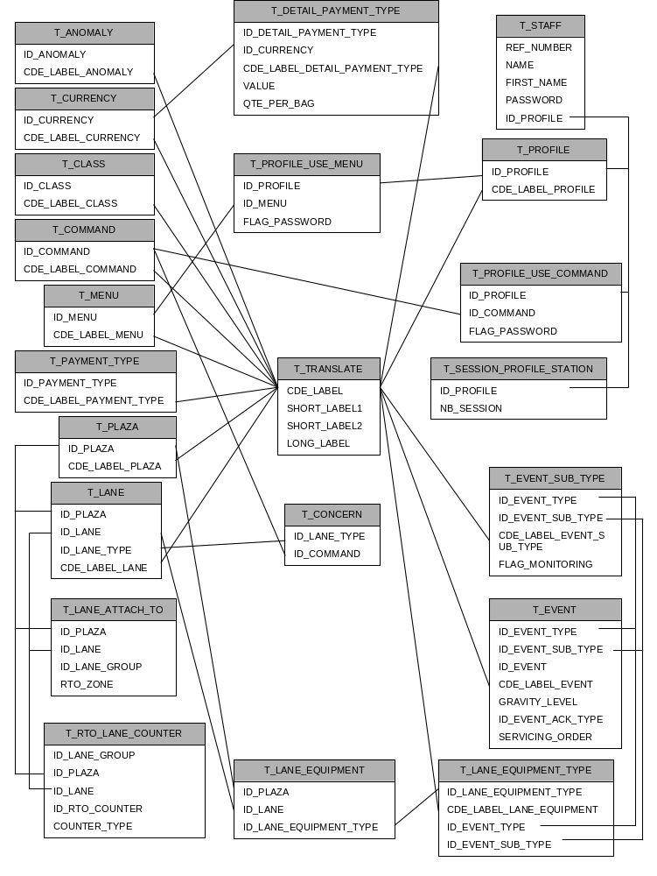

GEN_DEF (.INI)
Sets some general variables of the application:
- C_TYPE_EVENT_POSTE and C_SUB_TYPE_EVENT_STATUT : type and sub type of the events which refers to the lane shift (Example : open, closed, maintenance). A picture is displayed at the PV according to the state of this event (Lane window). The picture displayed is defined at the PV in the Type.txt file (ShiftX : where X represents the event state).
- C_TYPE_EVENT_POSTE and C_TYPE_SUB_EVENT_MODE_OUVERT : type and sub type of the events which refers to the lane opening mode (VAC, VM, VDT, …). A picture is displayed at the PV according to the state of this event (Lane window). The picture displayed is defined at the PV in the Type.txt file (ShiftXModeY : where Y represents the event state).
- C_TYPE_EVENT_CHENAL : Type of events which refers to the vault 1 status
- C_SUB_TYPE_EVENT_MARQUISE : Type of events which refers to the vault 2 status
Note : In case of configuration with database, GEN_DEF is not a table but a package where these variables are defined. Only one value for each variable is allowed. Variables access is provided by the call of stored procedure.

T_ANOMALY (.INI)
Lists the possible anomalies of transaction which can be sent by the lanes.
- ID_ANOMALY : anomaly Id
- CDE_LABEL_ANOMALY : label code referenced in T_TRANSLATE. Defines the label displayed at the PV in the ZLane window (AnomalyList).

T_CLASS (.INI)
Lists the possible class which can be sent by the lanes
- ID_CLASS : Class Id
- CDE_LABEL_CLASS : label code referenced in T_TRANSLATE. Defines the label displayed at the PV in the Lane, ZLane window (Class).

T_COMMAND (.INI)
Lists the possible commands which can be sent by the PV to the lanes
- ID_COMMAND : Command Id referenced at the PV in the command.txt file (between square brackets).
- CDE_LABEL_COMMAND : label code referenced in T_TRANSLATE. Defines the label displayed at the PV in the Command and Zcommand window (ListCommands).

T_CONCERN (.INI)
For each lane type, lists all the possible commands which can be sent by the PV.
- ID_LANE_TYPE : type of lane referenced at the PV in the type.txt file (between square brackets)
- ID_COMMAND : command Id referenced at the PV in the command.txt file (between square brackets)

T_CURRENCY (.INI)
Lists the possible currencies that can be accepted by the lane.
- ID_CURRENCY : currency Id.
- CDE_LABEL_CURRENCY : label code referenced in T_TRANSLATE. Defines the label displayed at the PV in the Lane, Zlane, TDetails window (Currency).

T_DETAIL_PAYMENT_TYPE (.INI)
Lists the possible coins that can be accepted by the lane.
- ID_DETAIL_PAYMENT_TYPE : coin Id
- ID_CURRENCY : currency Id (must be defined in T_CURRENCY).
- CDE_LABEL_DETAIL_PAYMENT_TYPE : label code referenced in T_TRANSLATE. Defines the label displayed at the PV in the VDetails, Zbowls, ZDisk window (Coin).
- VALUE : value corresponding to the coin.
- QTE_PER_BAG : quantity per bag (for the bowls filling).

T_EVENT (.INI)
Lists the possible events that can be sent by the lane.
- ID_EVENT_TYPE : Type of event (must be defined in T_EVENT_SUB_TYPE).
- ID_EVENT_SUB_TYPE : Sub type of event (must be defined in T_EVENT_SUB_TYPE).
- ID_EVENT : Event state
- CDE_LABEL_EVENT : label code referenced in T_TRANSLATE. Defines the label displayed at the PV in the Alarms, ZAlarms window (ListAlarms).
- GRAVITY_LEVEL : gravity level.
- ID_EVENT_ACK_TYPE : Type of event behaviour.
When a new event happened, all event with the same type and sub type is considered as out of date.
If sets to 0 : the new event is not displayed at the PV but all event with the same type and sub type becomes out of date.
If sets to 1 : The event cannot be released but is no longer displayed when out of date.
If sets to 2 : The event can be released but is no longer displayed when released and out of date.
If sets to 3 : The event is no longer displayed when out of date. As long as it is displayed, the event could be released.
If sets to 4 : The event is no longer displayed as soon as it is released, even if it is not out of date. (recommended for one shot events)
If sets to 5 : The event is no longer displayed as soon as it is released or out of date.
- SERVICING_ORDER : short label displayed at the PV in the Adetails window (Instructions).

T_EVENT_SUB_TYPE (.INI)
Lists the possible sub type of events that can be sent by the lane. Each event present in T_EVENT must be defined here.
- ID_EVENT_TYPE : Type of event .
- ID_EVENT_SUB_TYPE : Sub type of event.
- CDE_LABEL_EVENT_SUB_TYPE : label code referenced in T_TRANSLATE (not used).
- FLAG_MONITORING : if set to 0, all events with this type and sub type are ignored.

T_LANE (.INI)
Lists all the plaza lanes.
- ID_PLAZA : plaza Id (must be defined in T_PLAZA)
- ID_LANE : lane Id
- ID_LANE_TYPE : type of lane defined at the PV in the type.txt file (between square brackets)
- CDE_LABEL_LANE : label code referenced in T_TRANSLATE. Name of the lane.

T_LANE_ATTACH_TO (.INI)
Defines for each lane its membership to a group and a zone.
- ID_PLAZA : plaza Id (must be defined in T_PLAZA)
- ID_LANE : lane Id (must be defined in T_LANE)
- ID_LANE_GROUP : type of group defined at the PV in the DisplayXXXXXX.txt file (between square brackets)
- RTO_ZONE : type of zone defined at the PV in the ZoneXXXXX.txt file (between square brackets)

T_LANE_EQUIPMENT (.INI)
Defines for each lane the list of its equipments.
- ID_PLAZA : plaza Id (must be defined in T_PLAZA)
- ID_LANE : lane Id (must be defined in T_LANE)
- ID_LANE_EQUIPMENT_TYPE : (must be defined in T_LANE_EQUIPMENT_TYPE)

T_LANE_EQUIPMENT_TYPE (.INI)
Lists all the equipments that can be found on a lane. Each equipment is linked to a type and sub type of event that shows its state.
- ID_LANE_EQUIPMENT_TYPE : type of equipment defined at the PV in the Equipment.txt file (between square brackets)
- CDE_LABEL_LANE_EQUIPMENT : label code referenced in T_TRANSLATE (not used).
- ID_EVENT_TYPE : type of event (must be defined in T_EVENT_SUB_TYPE).
- ID_EVENT_SUB_TYPE : sub type of event (must be defined in T_EVENT_SUB_TYPE).

T_MENU (.INI)
Lists the possible functionalities that can be found in the menu bar of the PV.
- ID_MENU : type of menu defined at the PV in the Function.Txt file (between square brackets)
- CDE_LABEL_MENU : label code referenced in T_TRANSLATE (not used).

T_PAYMENT_TYPE (.INI)
Lists the possible types of payment that can be sent by the lane.
- ID_PAYMENT_TYPE : payment Id
- CDE_LABEL_PAYMENT_TYPE : label code referenced in T_TRANSLATE. Defines the label displayed at the PV in the Lane, Zlane, TDetails window (Payment Type).

T_PLAZA (.INI)
Defines the current plaza .
- ID_PLAZA : Plaza Id
- CDE_LABEL_PLAZA : label code referenced in T_TRANSLATE. Defines the plaza label displayed at the PV in the title bar.

T_PROFILE (.INI)
Lists the possible profiles of the PV users.
- ID_PROFILE : Profile Id
- CDE_LABEL_PROFILE : label code referenced in T_TRANSLATE. Defines the user profile displayed at the PV in the title bar.

T_PROFILE_USE_COMMAND (.INI)
Lists for each profile the access rights to the lane commands.
- ID_PROFILE : Profile Id (must exist in T_PROFILE)
- ID_COMMAND : Command Id ( must exist in T_COMMAND)
- FLAG_PASSWORD : if sets to 0, the command is allowed
If sets to 1, the command is password protected
If sets to empty string, the command is forbidden

T_PROFILE_USE_MENU (.INI)
Lists for each profile the access rights to the PV functions.
- ID_PROFILE : Profile Id (must exist in T_PROFILE)
- ID_MENU : Function Id ( must exist in T_MENU)
- FLAG_PASSWORD : If sets to 0, the function is allowed
If sets to 1, the function is password protected
If sets to empty string, the function is forbidden

T_RTO_LANE_COUNTER (.INI)
Lists the counters for each group of lanes and sets the lanes belonging to each counter.
- ID_LANE_GROUP : type of group (must be defined in T_LANE_ATTACH_TO)
- ID_PLAZA : plaza Id (must be defined in T_PLAZA)
- ID_LANE : lane Id (must be defined in T_LANE)
- ID_RTO_COUNTER : counter id. This counter is displayed at the PV in the status bar of the main window (DisplayXTotalY where X is the ID_LANE_GROUP and Y is the ID_RTO_COUNTER )
- COUNTER_TYPE : If sets to 0 : not counted
If sets to 1 : total traffic counter (since 0 hour).
If sets to 2 : total violation counter (since 0 hour)
If sets to 3 : unreleased events counter
If sets to 4 : total events counter
If sets to 5 : total traffic of the day before.

T_SESSION_PROFILE_STATION (.INI)
Defines for each profile, the number of sessions opened simultaneously.
- ID_PROFILE : Profile Id (must exist in T_PROFILE)
- NB_SESSION : max number of simultaneous sessions

T_STAFF (.INI)
Lists all the PV users with their passwords and profiles.
- REF_NUMBER : User Id
- NAME : User Name
- FIRST_NAME : User first name
- PASSWORD : User password
- ID_PROFILE : Profile Id (must exist in T_PROFILE)

T_TRANSLATE (.INI)
Lists all the labels used in the database tables or in INI files .
CDE_LABEL : Label Code
SHORT_LABEL1 : Short label 1 : used only for the name of the lanes.
SHORT_LABEL2 : Short label 2 : Never used
LONG_LABEL : Long label

Toll supervision CLIENT CONFIGURATION (PV)
The client application is composed of forms and controls (VB application). The application gives the possibility to edit some object properties. The available properties with their object type of application are given here after by alphabetical order.

AVAILABLE PROPERTIES
Properties | Type | Comment | Apply to
Alignment | Integer | Refers to VB documentation  0 Left  1 Right  2 Centred | SSCheck, SSFRame, SSOption, SSPanel, TextBox, Label, SSFrame, SSOption
BackColor | Color | Refers to VB documentation | ComboBox, Form, MDIForm, Label, ListBox, ListView, MaskEdBox, MsFlexGrid, Shape, SSPanel, SSRibbon, TextBox
BackColorFixed | Color | Refers to VB documentation | MsFlexGrid
BaudRate | Integer | Settings of the connection with a Zip KDE:  1200, 2400, 4800 et 9600 | CSRZip control
BevelInner | Integer | Refers to VB documentation | SSPanel
BevelOuter | Integer | Refers to VB documentation | SSPanel
BevelWidth | Integer | Refers to VB documentation | SSCommand, SSPanel, SSRibbon
BorderColor | Color | Refers to VB documentation | Line, Shape
BorderWidth | Integer | Refers to VB documentation | Line, Shape, SSPanel
Caption | Text | Refers to VB documentation | Form, MDIForm, Label, Menu, SSCheck, SSCommand, SSFrame, SSOption, SSPanel
Colalignment(n) | Integer | Refers to VB documentation | MsFlexGrid
ColCaption(n) | Text | Sets the title of the column n | MSFlexGrid
ColFormat(n) | Text | Sets the data format for the column n | MSFlexGrid
Columns | Integer | Refers to VB documentation | Refers to VB documentation
ColumnHeadersAlignment(n) | Integer | Sets the data alignment for the column n  0 left  1 right  2 centred | ListView
ColumnHeadersFormat(n) | Text | Sets the data format for the column n | ListView
ColumHeadersText(n) | Text | Sets the title of the column n | ListView
ColumnHeadersWidth(n) | Integer | Sets the width of the column n | ListView
ColWidth(n) | Integer | Sets the width of the colimn n | MsFlexGrid
CustomFormat | Text | Refers to VB documentation | DTPicker
DataLength | Integer | Settings of the connection with a Zip KDE:  7 or 8 (bits) | CSRZip
Duration | Long Integer | Sets the number of milliseconds between calls to a timer event. | Timer
Enabled | Bool | Refers to VB documentation | ComboBox, DTPicker, Form, MDIForm, Image, Label, ListBox, ListView, MaskEdBox, Menu, MsFlexGrid, PictureBox, SSCheck, SSCommand, SSFrame, SSOption, SSPanel, SSRibbon, SSTab, TextBox, Timer
FileName | Text | Refers to VB documentation | CommonDialog
FillColor | Color | Refers to VB documentation | Form, MDIForm, Shape
FontBold | Bool | Refers to VB documentation | ComboBox, DTPicker, Form, MDIForm, Label, ListBox, ListView, MaskEdBox, MsFlexGrid, SSCheck, SSCommand, SSFrame, SSOption, SSPanel, TextBox
FontItalic | Bool | Refers to VB documentation | ComboBox, DTPicker, Form, MDIForm, Label, ListBox, ListView, MaskEdBox, MsFlexGrid, SSCheck, SSCommand, SSFrame, SSOption, SSPanel, TextBox
FontName | Text | Refers to VB documentation | ComboBox, DTPicker, Form, MDIForm, Label, ListBox, ListView, MaskEdBox, MsFlexGrid, SSCheck, SSCommand, SSFrame, SSOption, SSPanel, TextBox
FontSize | Integer | Refers to VB documentation | ComboBox, DTPicker, Form, MDIForm, Label, ListBox, ListView, MaskEdBox, MsFlexGrid, SSCheck, SSCommand, SSFrame, SSOption, SSPanel, TextBox
Font3D | Integer | Refers to VB documentation | SSCheck, SSCommand, SSFrame, SSOption, SSPanel
Format | Text | Refers to VB documentation | SSPanel
ForeColor | Color | Refers to VB documentation | ComboBox, Form, MDIForm, Label, ListBox, ListView, MaskEdBox, MsFlexGrid, SSCheck, SSCommand, SSFrame, SSOption, SSPanel, TextBox
Height | Integer | Refers to VB documentation | ComboBox, DTPicker, Form, MDIForm, Image, Label, ListBox, ListView, MaskEdBox, MsFlexGrid, PictureBox, Shape, SSCheck, SSCommand, SSFrame, SSOption, SSPanel, SSRibbon, SSTab, TextBox
HelpFile | Text | Refers to VB documentation | CommonDialog
HideColumnHeaders | Bool | Refers to VB documentation | ListView
HideSelection | Bool | Refers to VB documentation | ListView
Icon | Text | Refers to VB documentation | Form, MDIForm
Image(key) | Text | Loads a picture and links it to a key word | ImageList
InstanceFileName | Text | Refers to CSRAcom documentation  Machine name or address for the named pipe connection. | CSRAcomInstance
InstanceType | Integer | Refers to CSRAcom documentation  Type of connection  0 none  1 pipe server  2 pipe client  3 mailslot server  4 mailslot client | CSRAcomInstance
Left | Integer | Refers to VB documentation | ComboBox, DTPicker, Form, MDIForm, Image, Label, ListBox, ListView, MaskEdBox, MsFlexGrid, PictureBox, Shape, SSCheck, SSCommand, SSFrame, SSOption, SSPanel, SSRibbon, SSTab, TextBox
LifeTime | Integer | Refers to CSRAcom documentation  Interval between life messages (life protocol) | CSRAcomWorkingSet
List(n) | Text | Refers to VB documentation | ComboBox, ListBox
Mask | Text | Refers to VB documentation | MaskEdBox
MaxLength | Integer | Refers to VB documentation | MaskEdBox, TextBox
MaxLife | Integer | Refers to CSRAcom documentation  Max number of life message with no response | CSRAcomWorkingSet
MaxMessageSize | Integer | Refers to CSRAcom documentation  Max message size | CSRAcomInstance
OutLine | Bool | Refers to VB documentation | SSCommand, SSPanel, SSRibbon
Parity | Integer | Settings of the connection with a Zip KDE:  0-NONE  1-EVEN  2-ODD | CSRZip
Picture | Text | Refers to VB documentation | Form, MDIForm, Image, PictureBox, SSCommand
PictureUp | Text | Refers to VB documentation | SSRibbon
PictureDn | Text | Refers to VB documentation | SSRibbon
PortNumber | Integer | Settings of the connection with a Zip KDE:  0–COM1  1–COM2 | CSRZip
Priority | Integer | Refers to CSRAcom documentation  Priority of the communication task  -15 null  -2 low  -1 below normal  0 normal  1 above normal  2 highest  15 time critical | CSRAcomWorkingSet
ReadTimer | Integer | Max Time to read a zip card | CSRZip
ReconnectDelay | Integer | Refers to CSRAcom documentation  Reconnection delay after a disconnection | CSRAcomInstance
RowCaption(n) | Text | Caption of the row n | MsFlexGrid
RowHeight(n) | Integer | Height of the row n | MsFlexGrid
Shape | Integer | Refers to VB documentation | Shape
Stretch | Bool | Refers to VB documentation | Image
TabCaption(n) | Text | Refers to VB documentation | SSTab
Text | Text | Refers to VB documentation | ComboBox, TextBox
ToolTipText | Text | Refers to VB documentation | ComboBox, DTPicker, Image, Label, ListBox, ListView, MaskEdBox, MsFlexGrid, PictureBox, SSCheck, SSCommand, SSFrame, SSOption, SSPanel, SSRibbon, TextBox
Top | Integer | Refers to VB documentation | ComboBox, DTPicker, Form, MDIForm, Image, Label, ListBox, ListView, MaskEdBox, MsFlexGrid, PictureBox, Shape, SSCheck, SSCommand, SSFrame, SSOption, SSPanel, SSRibbon, SSTab, TextBox
Value | Bool | Refers to VB documentation | SSCheck, SSOption, SSRibbon
Visible | Bool | Refers to VB documentation | ComboBox, DTPicker, Form, MDIForm, Image, Label, ListBox, ListView, MaskEdBox, Menu, MsFlexGrid, PictureBox, Shape, SSCheck, SSCommand, SSFrame, SSOption, SSPanel, SSRibbon, SSTab, TextBox
Width | Integer | Refers to VB documentation | ComboBox, DTPicker, Form, MDIForm, Image, Label, ListBox, ListView, MaskEdBox, MsFlexGrid, PictureBox, Shape, SSCheck, SSCommand, SSFrame, SSOption, SSPanel, SSRibbon, SSTab, TextBox

APPLICATION OBJECTS

About
Function : General application information. This form is available through the “MenuHelpAbout” menu from the “Plaza” form. “Exit” button to close the form.
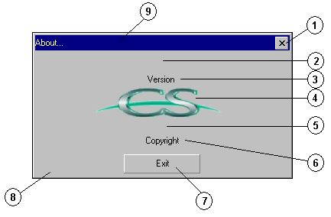
N° | object name | Type
0 | About | Form
1 | TitleButton1 | SSRibbon
2 | ProductName | SSPanel
3 | Version | SSPanel
4 | Logo | Image
5 | CompanyName | SSPanel
6 | LegalCopyright | SSPanel
7 | Exit | SSCommand
8 | Panel | SSPanel
9 | Title | SSPanel

Adetails
Function : Detailed event information. This form is available through the “Detail” control of the “Alarms” form. “Exit” button to close the form.
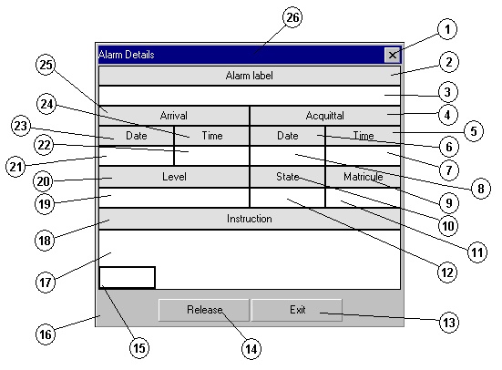
N° | Object name | Type
0 | Adetails | Form
1 | TitleButton1 | SSRibbon
2 | LabelTitle | SSPanel
3 | Label | SSPanel
4 | AcquittalTitle | SSPanel
5 | AcquittalTimeTitle | SSPanel
6 | AcquittalDateTitle | SSPanel
7 | AcquittalTime | SSPanel
8 | AcquittalDate | SSPanel
9 | MatriculeTitle | SSPanel
10 | StateTitle | SSPanel
11 | Matricule | SSPanel
12 | State | SSPanel
13 | Exit | SSCommand
14 | Release | SSCommand
15 | GridState | MsFlexGrid
16 | Panel | SSPanel
17 | Instruction | SSPanel
18 | InstructionTitle | SSPanel
19 | Level | SSPanel
20 | LevelTitle | SSPanel
21 | ArrivalDate | SSPanel
22 | ArrivalTime | SSPanel
23 | ArrivalTimeTitle | SSPanel
24 | ArrivalDateTitle | SSPanel
25 | ArrivalTitle | SSPanel
26 | Title | SSPanel

Alarms
Function : List the lane events. This form is available through the “MenuActionAlarms” menu of the “Plaza” form. “Exit” button to close the form.
N° | Object name | Type
0 | Alarms | Form
1 | TitleButton1 | SSRibbon
2 | AlarmsTitle | SSPanel
3 | ListAlarms | ListView
3 | ListAlarmsPanel | SSPanel
4 | Panel | SSPanel
5 | Exit | SSCommand
6 | ReleaseAll | SSCommand
7 | Detail | SSCommand
8 | ListLanes | ListBox
9 | LaneTitle | SSPanel
10 | ListLaneDsp | ListBox
11 | DisplayTitle | SSPanel
12 | ListLaneType | ListBox
13 | TypeTitle | SSPanel
14 | Title | SSPanel
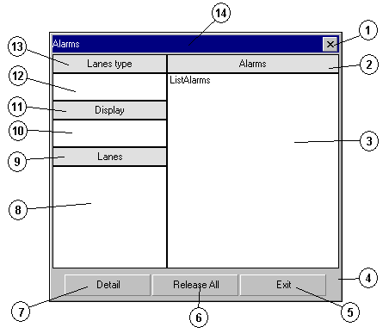

Album
Function : Inventory of all the pictures of the application. This form is never visible.
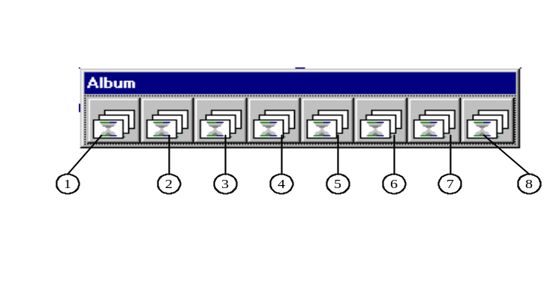
N° | Object name | Type
0 | Album | Form
1 | Plaza | ImageList
2 | Alarms | ImageList
3 | Lane | ImageList
4 | Equipment | ImageList
5 | Connect | ImageList
6 | Authentication | ImageList
7 | Anomaly | ImageList
8 | Transactions | ImageList

Authentication
Function : User authentication for the password protected functions. This form is displayed when clicking on a password protected function. “Cancel” button to close the form.
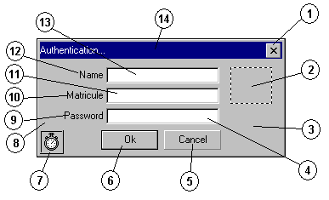
N° | Object name | Type
0 | Authentication | Form
1 | TitleButton1 | SSRibbon
2 | Logo | Image
3 | Panel | SSPanel
4 | PasswordText | TextBox
5 | Cancel | SSCommand
6 | Ok | SSCommand
7 | Timer | Timer
8 | KeyIn | SSPanel
9 | PasswordTitle | SSPanel
10 | MatriculeTitle | SSPanel
11 | MatriculeText | MaskEdBox
12 | NameTitle | SSPanel
13 | NameText | TextBox
14 | Title | SSPanel

BControle
Function : Manage the bowls for all the lanes. This form is available through the “MenuActionBowlsControl” menu of the “Plaza” form. “Exit” button to close the form.
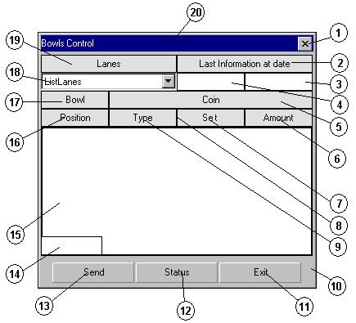
N° | Object name | Type
0 | Bcontrôle | Form
1 | TitleButton1 | SSRibbon
2 | LastInfoTitle | SSPanel
3 | LastInfoTime | SSPanel
4 | LastInfoDate | SSPanel
5 | CoinTitle | SSPanel
6 | AmountTitle | SSPanel
7 | SetTitle | SSPanel
8 | QuantityTitle | SSPanel
9 | TypeTitle | SSPanel
10 | Panel | SSPanel
11 | Exit | SSCommand
12 | Status | SSCommand
13 | Send | SSCommand
14 | KeyInText | TextBox
15 | GridBowl | MsFlexGrid
16 | PositionTitle | SSPanel
17 | Bowltitle | SSPanel
18 | ListLanes | ComboBox
19 | LaneTitle | SSPanel
20 | Title | SSPanel

Beeps
Function : Manage the event sounds. This form is never visible.

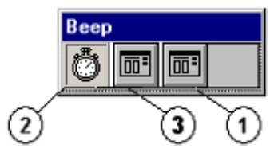
N° | Object name | Type
0 | Beeps | Form
1 | Sound | CommonDialog
2 | Timer | Timer
3 | SingleSound | CommonDialog

Bemptying
Function : Manage the bowls emptying for the lanes. This form is available through the “MenuActionBowlsEmptying” menu of the “Plaza” form. “Exit” button to close the form.

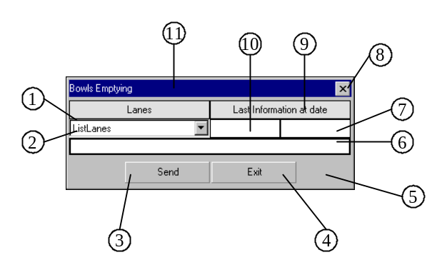
N° | Object name | Type
0 | Bemptying | Form
1 | LaneTitle | SSPanel
2 | ListLanes | ListBox
3 | Send | SSCommand
4 | Exit | SSCommand
5 | Panel | SSPanel
6 | GridBowl | MSFlexGrid
7 | LastInfoTime | SSPanel
8 | TitleButton1 | SSRibbon
9 | LastInfoTitle | SSPanel
10 | LastInfoDate | SSPanel
11 | Title | SSPanel

Bfilling
Function : Manage the bowls filling for the lane. This form is available through the “MenuActionBowlsFilling” menu of the “Plaza” form. “Exit” button to close the form.
N° | Object name | Type
0 | Bfilling | Form
19 | Title | SSPanel
1 | TitleButton1 | SSRibbon
2 | LastInfoTitle | SSPanel
3 | LastInfoTime | SSPanel
4 | LastInfoDate | SSPanel
5 | BagTitle | SSPanel
6 | AmountTitle | SSPanel
7 | AddTitle | SSPanel
8 | TypeTitle | SSPanel
9 | Panel | SSPanel
10 | Exit | SSCommand
11 | Status | SSCommand
12 | Send | SSCommand
13 | KeyInText | TextBox
14 | GridBowl | MsFlexGrid
15 | PositionTitle | SSPanel
16 | Bowltitle | SSPanel
17 | ListLanes | ComboBox
18 | LaneTitle | SSPanel
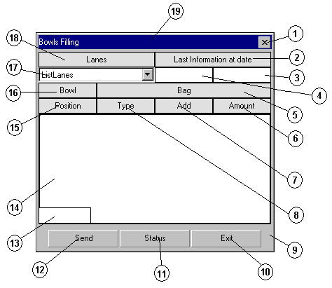

Bprinting
Function : Manage the bowls printing for the lane. This form is available through the “MenuActionBowlsPrinting” menu of the “Plaza” form. “Exit” button to close the form.
N° | Object name | Type
0 | Bprinting | Form
1 | Title | SSPanel
2 | LanesTitle | SSPanel
3 | TitleButton1 | SSRibbon
4 | LastInfoTitle | SSPanel
5 | GridLanes | MsFlexGrid
6 | Panel | SSPanel
7 | Exit | SSCommand
8 | Status | SSCommand
9 | Continue | SSCommand
10 | ListLanes | ListBox
11 | LaneTitle | SSPanel
12 | TotalAmountOption | CheckBox
13 | SupplementOption | CheckBox
14 | ContentsOption | CheckBox
15 | PrintTypeTitle | SSPanel
16 | PrintTypePanel | SSPanel
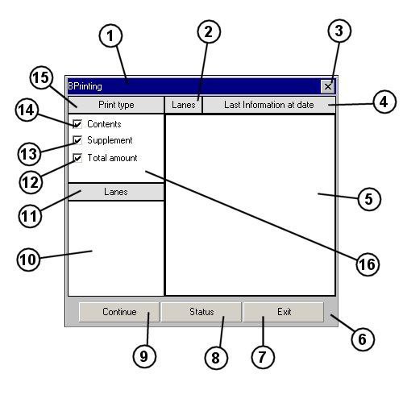

Bowls
Function : Bowls state for all the lanes. This form is available through the “MenuActionBowlsState” menu of the “Plaza” form. “Exit” button to close the form.
N° | Contrôle | Type
0 | Bowls | Form
1 | TitleButton1 | SSRibbon
2 | LastInfoTitle | SSPanel
3 | LastInfoDate | SSPanel
4 | LastInfoTime | SSPanel
5 | CoinTitle | SSPanel
6 | QuantityTitle | SSPanel
7 | TypeTitle | SSPanel
8 | Panel | SSPanel
9 | Exit | SSCommand
10 | Status | SSCommand
11 | GridBowl | MsFlexGrid
12 | FillingTitle | SSPanel
13 | PositionTitle | SSPanel
14 | Bowltitle | SSPanel
15 | ListLanes | ComboBox
16 | LaneTitle | SSPanel
17 | Title | SSPanel
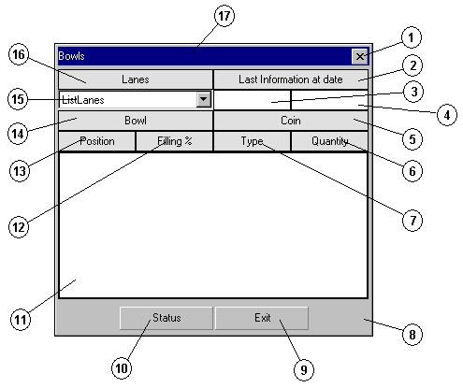

Cdetails
Function : Key in the lane commands parameters. This form is displayed when clicking on the “Continue” button of the “Command” form. “Exit” button to close the form.
N° | Object name | Type
0 | Cdetails | Form
1 | Option1 to 4 | SSOption
2 | TextTitle | SSPanel
3 | ShortText | TextBox
4 | LongText | TextBox
5 | Id | TextBox
6 | Cd | TextBox
7 | CommandType | TextBox
8 | ListLanes | ListBox
9 | Send | SSCommand
10 | Exit | SSCommand
11 | NoDisplay | SSCheck
12 | Panel | SSPanel
13 | Title1 to 8 | SSPanel
14 | Date1 to 4 | DTPicker
15 | Label | SSPanel
16 | TitleButton1 | SSRibbon
17 | Title | SSPanel
18 | Text1 to 4 | TextBox
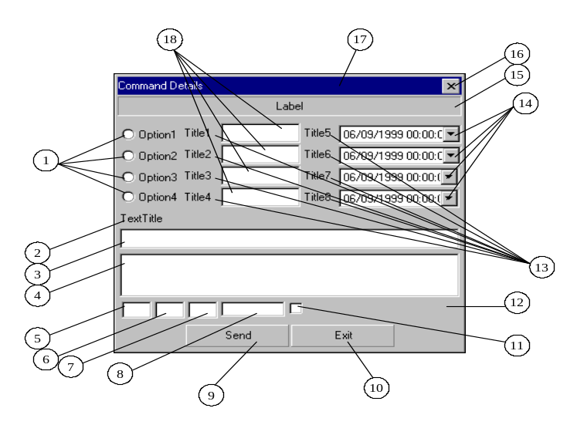

Commands
Function : List the commands for all the lane. This form is available through the “MenuActionCommands” menu of the “Plaza” form. “Exit” button to close the form.
N° | Object name | Type
0 | Commands | Form
1 | TitleButton1 | SSRibbon
2 | CommandTitle | SSPanel
3 | ListCommands | ListView
3 | ListCommandsPanel | SSPanel
4 | Panel | SSPanel
5 | Exit | SSCommand
6 | Continue | SSCommand
7 | ListLanes | ListBox
8 | LaneTitle | SSPanel
9 | ListLaneDsp | ListBox
10 | DisplayTitle | SSPanel
11 | ListLaneType | ListBox
12 | TypeTitle | SSPanel
13 | Title | SSPanel
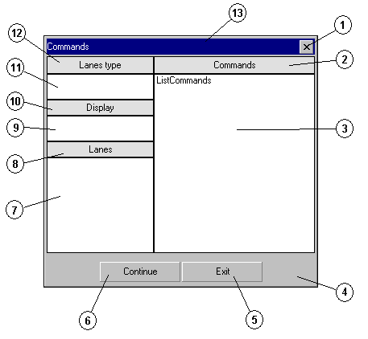

Communicate
Function : Manage the connection with the server. This form is never visible.

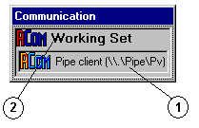
N° | Contrôle | Type
0 | Communicate | Form
1 | AComPipe | CSRAComInstance
2 | AComSession | CSRAComWorkingSet

Connect
Function : Identification of the user to open a session. This form is displayed when clicking on the “MenuSessionNew” menu of the “Plaza” form. “Cancel” button to close the form.
N° | Object name | Type
0 | Connect | Form
1 | TitleButton1 | SSRibbon
2 | Logo | Image
3 | Panel | SSPanel
4 | PasswordText | TextBox
5 | Cancel | SSCommand
6 | Ok | SSCommand
7 | Timer | Timer
8 | KeyIn | SSPanel
9 | PasswordTitle | SSPanel
10 | MatriculeTitle | SSPanel
11 | MatriculeText | MaskEdBox
12 | NameTitle | SSPanel
13 | NameText | TextBox
14 | Title | SSPanel
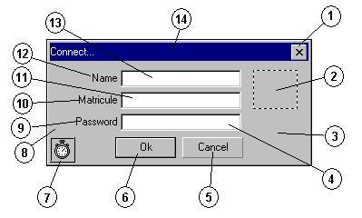

Counting
Function : display the result of the part time counting. This form is available through the “MenuActionCounting” menu of the “Plaza” form. “Exit” button to close the form.
N° | Object name | Type
0 | Counting | Form
1 | TypeTitle | SSPanel
2 | ListLaneType | ListBox
3 | DisplayTitle | SSPanel
4 | ListLaneDsp | ListBox
5 | ListLanes | ListBox
6 | Print | SSCommand
7 | Exit | SSCommand
8 | Panel | SSPanel
9 | GridLanes | MSFlexGrid
10 | LanesTitle | SSPanel
11 | TrafficTitle | SSPanel
12 | ViolationTitle | SSPanel
13 | TitleButton1 | SSRibbon
14 | Title | SSPanel
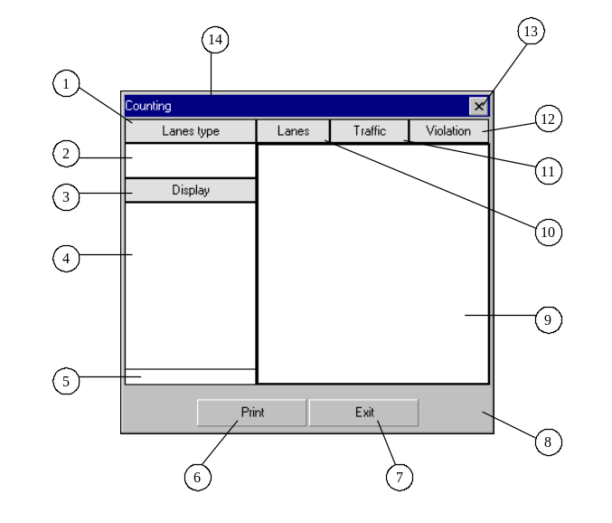

Disconnect
Function : Close the current user session (if it is not the default user session) if during a fixed time, no mouse activity is detected. This form is never visible.

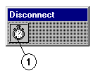
N° | Object name | Type
0 | Disconnect | Form
1 | Timer | Timer

Disk
Function : display the disk state. This form is available through the “MenuActionDisk” menu of the “Plaza” form. “Exit” button to close the form.
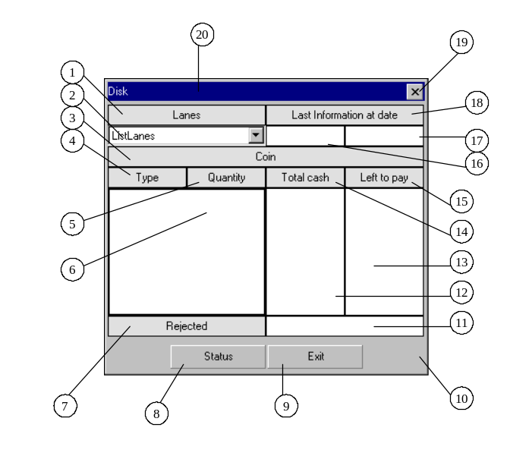
N° | Object name | Type
0 | Disk | Form
1 | LaneTitle | SSPanel
2 | ListLanes | ComboBox
3 | CoinTitle | SSPanel
4 | TypeTitle | SSPanel
5 | QuantityrTitle | SSPanel
6 | GridDisk | MsFlexGrid
7 | RejectedTitle | SSPanel
8 | Status | SSCommand
9 | Exit | SSCommand
10 | Panel | SSPanel
11 | Rejected | SSPanel
12 | TotalCash | SSPanel
13 | LeftToPay | SSPanel
14 | TotalCashTitle | SSPanel
15 | LeftToPayTitle | SSPanel
16 | LastInfoDate | SSPanel
17 | LastInfoTime | SSPanel
18 | LastInfoTitle | SSPanel
19 | TitleButton1 | SSRibbon
20 | Title | SSPanel

Icon
Function : Lane window when minimized. This form is displayed when clicking on the “TitleButton1” button of the “Lane” form.

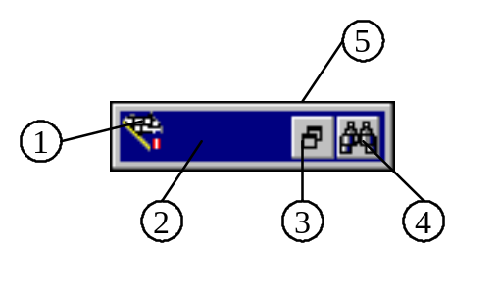
N° | Object name | Type
0 | Icon | Form
1 | TitlePicture | PictureBox
2 | Title | SSPanel
3 | TitleButton1 | SSRibbon
4 | TitleButton2 | SSRibbon
5 | Panel | SSPanel

Lane
Function : Lane state. Opened when a user is logged.
N° | Object name | Type
0 | Lane | Form
1 | TitleButton1 | SSRibbon
2 | TitleButton2 | SSRibbon
3 | Class | SSPanel
4 | EquipmentGrid | MSFlexGrid
5 | LaneTypeimage | Image
6 | Line1 | Line
7 | Line2 | Line
8 | CollectorNumber | SSPanel
9 | Panel | SSPanel
10 | LaneTypePanel | SSPanel
11 | AckEvent | SSPanel
12 | Event | SSPanel
13 | UnackEvent | SSPanel
14 | ActiveVaultId | SSPanel
15 | Timer | Timer
16 | PaymentType | SSPanel
17 | Currency | SSPanel
18 | TollFare | SSPanel
19 | CanopyImage | Image
20 | TobleroneImage | Image
21 | Canopy | SSPanel
22 | Toblerone | SSPanel
23 | TitlePicture | PictureBox
24 | Title | SSPanel
25 | ClassBis | Label
26 | ClassBisTitle | Label
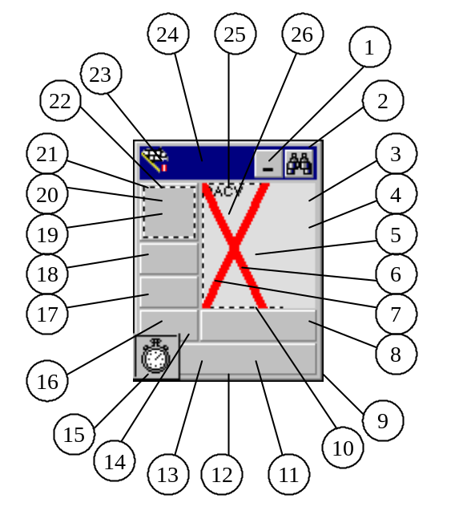

Limits
Function : manage the part time counting. This form is available through the “MenuActionCountingPartialLimited” menu of the “Plaza” form. “Exit” button to close the form.
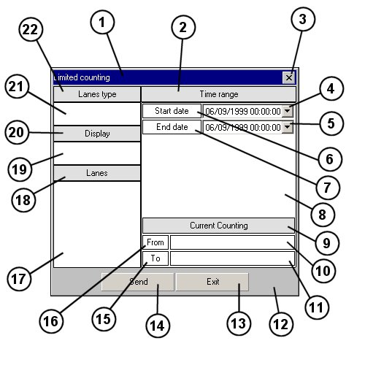
N° | Object name | Type
0 | Limits | Form
1 | Title | SSPanel
2 | TimeRangeTitle | SSPanel
3 | TitleButton1 | SSRibbon
4 | StartDate | DTPicker
5 | EndDate | DTPicker
6 | StartDateTitle | SSPanel
7 | EndDateTitle | SSPanel
8 | TimeRangePanel | SSPanel
9 | CurrentCountingTitle | SSPanel
10 | CurrentStartDate | SSPanel
11 | CurrentEndDate | SSPanel
12 | Panel | SSPanel
13 | Exit | SSCommand
14 | Send | SSCommand
15 | CurrentEndDateTitle | SSPanel
16 | CurrentStartDateTitle | SSPanel
17 | ListLanes | ListBox
18 | LaneTitle | SSPanel
19 | ListLaneDsp | SSPanel
20 | DisplayTitle | SSPanel
21 | ListLaneType | ComboBox
22 | TypeTitle | SSPanel

Menu
Function : Lane zoom contextual menu. This form is never visible.
N° | Object name | Type
0 | Menu | Form
1 | MenuContext | Menu
2 | MenuContextAlarms | Menu
3 | MenuContextCommands | Menu
4 | MenuContextTransactions | Menu
5 | MenuContextLane | Menu
6 | MenuContextDisk | Menu
7 | MenuContextBowls | Menu
8 | MenuContextVaults | Menu
9 | MenuContextSnapShot | Menu
10 | MenuContextVES | Menu
11 | MenuSystem | Menu
12 | MenuSystemRestore | Menu
13 | MenuSystemMove | Menu
14 | MenuSystemMinimize | Menu
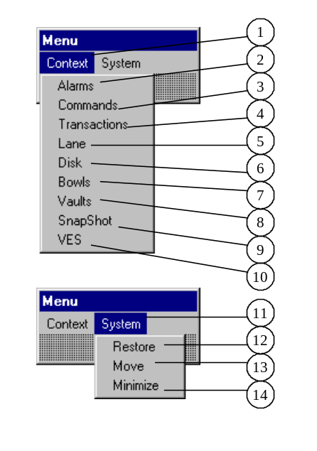

MsgE
Function : display service messages from the server. This form is displayed in case of service message form the server.
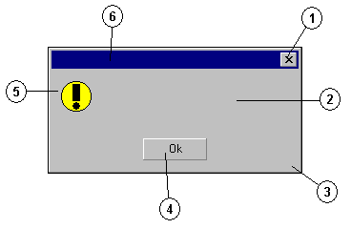
N° | Object name | Type
0 | MsgE | Form
1 | TitleButton1 | SSRibbon
2 | Text | SSPanel
3 | Panel | SSPanel
4 | MsgButton1 | SSCommand
5 | Image | Image
6 | Title | SSPanel

MsgI
Function : Display service messages from the application.
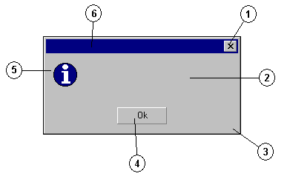
N° | Object name | Type
0 | MsgE | Form
1 | TitleButton1 | SSRibbon
2 | Text | SSPanel
3 | Panel | SSPanel
4 | MsgButton1 | SSCommand
5 | Image | Image
6 | Title | SSPanel

MsgQ
Function : Confirmation window.

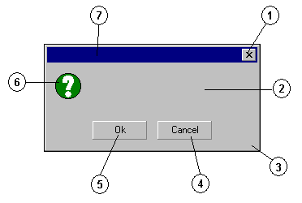
N° | Object name | Type
0 | MsgQ | Form
1 | TitleButton1 | SSRibbon
2 | Text | SSPanel
3 | Panel | SSPanel
4 | MsgButton1 | SSCommand
5 | MsgButton2 | SSCommand
6 | Image | Image
7 | Title | SSPanel

Options
N° | Object name | Type
0 | Options | Form
1 | ConnectOptions | SSFrame
2 | ConnectKeepMatricule | SSCheck
3 | ConnectKeepName | SSCheck
4 | OnDisconnectionOptions | SSFrame
5 | OnDisconnectionRelogLastUser | SSCheck
6 | OnDisconnectionRelogDefaultUser | SSCheck
7 | OnDisconnectionKeepSession | SSCheck
8 | ApplicationOptions | SSFrame
9 | ApplicationMutexUse | SSCheck
10 | TabOptions | SSTab
11 | Exit | SSCommand
12 | Panel | SSPanel
13 | TracesMaxSizeLabel | Label
14 | TracesMaxSize | TextBox
15 | TracesLocation | TextBox
16 | TracesOptions | SSCheck
17 | TracesActive | SSCheck
18 | AuthenticationOptions | SSFrame
19 | TitleButton1 | SSRibbon
20 | AuthenticationKeepMatricule | SSCheck
21 | AuthenticationKeepName | SSCheck
22 | Title | SSPanel
Function : General application settings. This form is never visible.
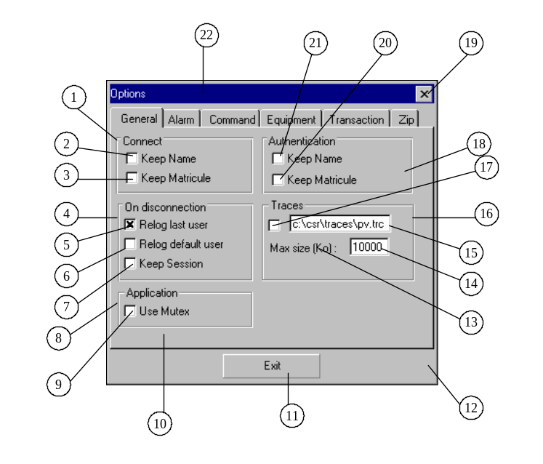
N° | Comment
2 | The previous keyed in collector id not erased in the connect window
3 | The previous keyed collector name is not erased in the connect window
5 | In case of failure and retrieval of connection with the server, the last user will be logged again
6 | In case of failure and retrieval of connection with the server, the default user will be logged again
7 | In case of connection failure with the server, the session is not closed
9 | Only one application can be launched at a time
14 | Max size in Ko of the trace file (debug)
15 | Path of the trace file
17 | Activate the traces
20 | The previous keyed in collector id not erased in the authentication window
21 | The previous keyed collector name is not erased in the authentication window

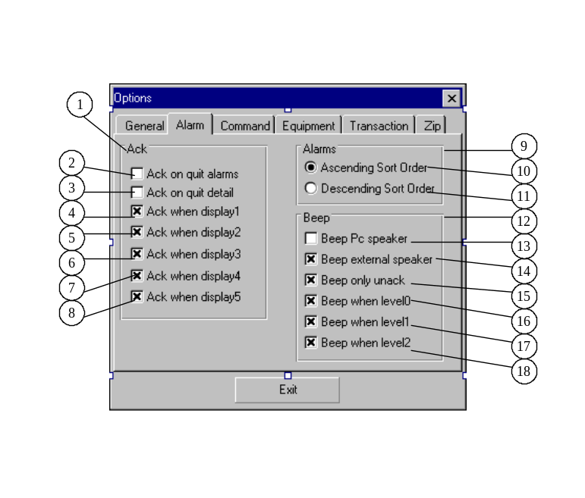
N° | Object name | Type
1 | AckOptions | SSFrame
2 | AckOnQuitAlarms | SSCheck
3 | AckOnQuitDetail | SSCheck
4 | AckWhenDisplay1 | SSCheck
5 | AckWhenDisplay2 | SSCheck
6 | AckWhenDisplay3 | SSCheck
7 | AckWhenDisplay4 | SSCheck
8 | AckWhenDisplay5 | SSCheck
9 | AlarmsOptions | SSFrame
10 | AlarmsDescendingSortOrder | SSOption
11 | AlarmsAscendingSortOrder | SSOption
12 | BeepOptions | SSFrame
13 | BeepPcSpeaker | SSCheck
14 | BeepExternalSpeaker | SSCheck
15 | BeepOnlyUnack | SSCheck
16 | BeepWhenLevel0 | SSCheck
17 | BeepWhenLevel1 | SSFrame
18 | BeepWhenLevel2 | SSCheck
N° | Comment
2 | Released all the events displayed in the ZAlarms window when is closed
3 | Released the event displayed in the Adetail window when is closed
4 | Release events is enabled for the lanes of the display 1
5 | Release events is enabled for the lanes of the display 2
6 | Release events is enabled for the lanes of the display 3
7 | Release events is enabled for the lanes of the display 4
8 | Release events is enabled for the lanes of the display 5
10 | Events sorted in the list by descending order of their arrival in the Alarms and Zalarms window
11 | Events sorted in the list by ascending order of their arrival in the Alarms and Zalarms window
13 | Beep by using the PC beep
14 | Beep by playing a sound file
15 | Beep only when unreleased event is present
16 | Beep when an event of level 0 is present
17 | Beep when an event of level 1 is present
18 | Beep when an event of level 2 is present

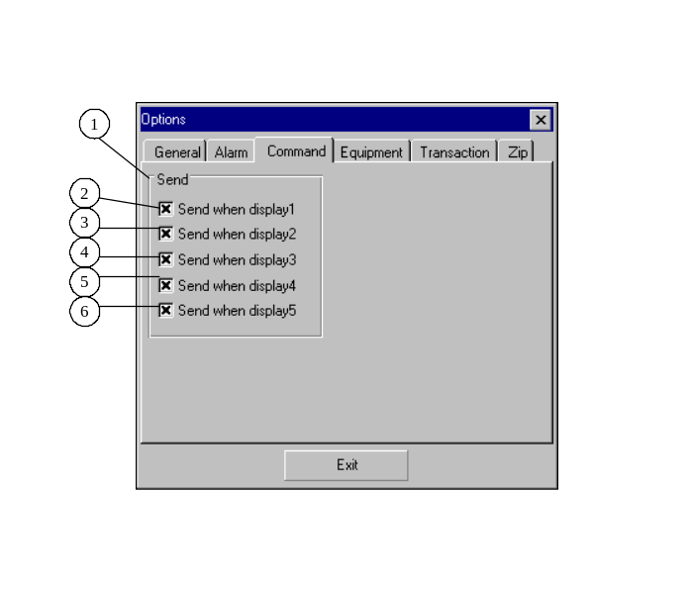
N° | Object name | Type
1 | SendOptions | SSFrame
2 | SendWhenDisplay1 | SSCheck
3 | SendWhenDisplay2 | SSCheck
4 | SendWhenDisplay3 | SSCheck
5 | SendWhenDisplay4 | SSCheck
6 | SendWhenDisplay5 | SSCheck
N° | Comment
2 | Send commands is enabled for the lane of the display 1
3 | Send commands is enabled for the lane of the display 2
4 | Send commands is enabled for the lane of the display 3
5 | Send commands is enabled for the lane of the display 4
6 | Send commands is enabled for the lane of the display 5

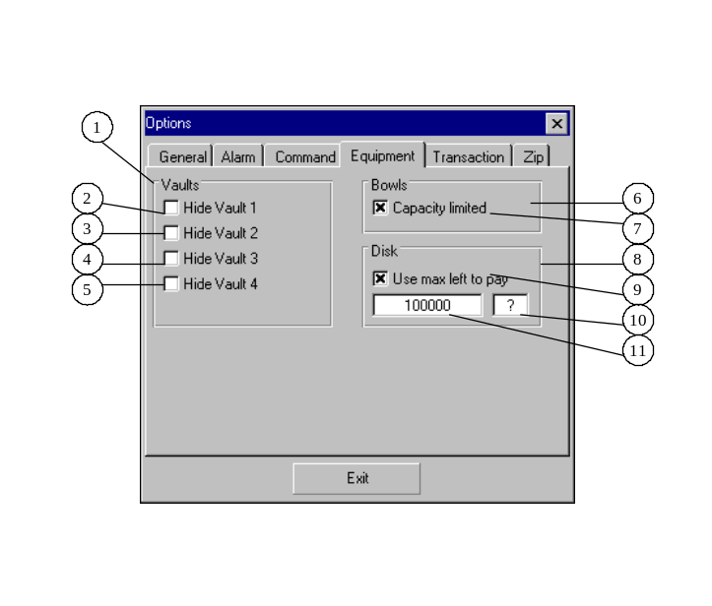
N° | Object name | Type
1 | VaultsOptions | SSFrame
2 | HideVault1 | SSCheck
3 | HideVault 2 | SSCheck
4 | HideVault 3 | SSCheck
5 | HideVault 4 | SSCheck
6 | BowlsOptions | SSFrame
7 | BowlsCapacityLimited | SSCheck
8 | DiskOptions | SSFrame
9 | UseMaximumLeftToPay | SSCheck
10 | MaximumLeftToPayText | TextBox
11 | MaximumLeftToPay | TextBox
N° | Comment
2 | The vault 1 is not displayed in the Vaults window
3 | The vault 2 is not displayed in the Vaults window
4 | The vault 3 is not displayed in the Vaults window
5 | The vault 4 is not displayed in the Vaults window
7 | The bowls capacity is limited for the Bcontrol window
9 | The left to pay value is limited for the Zdisl window
10 | Sets the max for left to pay value for the Zdisk window
11 | Sets the label to display if the left to pay exceeds the max

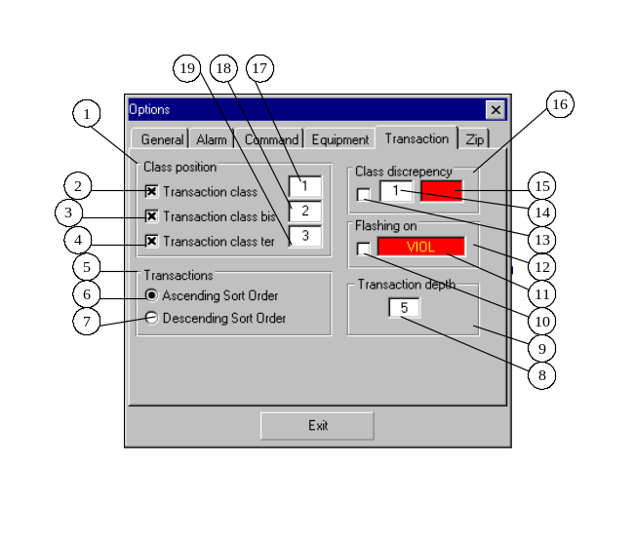
N° | Object name | Type
1 | ClassPositionOptions | SSFrame
2 | TransactionClassVisibleWhenNull | SSCheck
3 | TransactionClassBisVisibleWhenNull | SSCheck
4 | TransactionClassTerVisibleWhenNull | SSCheck
5 | TransactionsOption | SSFrame
6 | TransactionsAscendingSortOrder | SSOption
7 | TransactionsDescendingSortOrder | SSOption
8 | TransactionDepth | TextBox
9 | TransactionDepthOptions | SSFrame
10 | FlashingOnPayment | SSCheck
11 | FlashingOn | TextBox
12 | FlashingOnOptions | SSFrame
13 | TransactionClassDiscrepencyShow | SSCheck
14 | TransactionClassDiscrepency | TextBox
15 | TransactionClassDiscrepencyForeColor | TextBox
16 | ClassDiscrepencyOptions | SSFrame
17 | TransactionClass | TextBox
18 | TransactionClassBis | TextBox
19 | TransactionClassTer | TextBox
N° | Comment
2 | Displaying the class when = 00 or not?
3 | Displaying the classbis when = 00 or not?
4 | Displaying the classter when = 00 or not?
6 | Transactions sorted in the list by descending order of their arrival in the transactions and Ztransactions window
7 | Transactions sorted in the list by descending order of their arrival in the transactions and Ztransactions window
8 | Number of transactions displayed in the transaction list of the transactions and Ztransactions window
10 | The payment type panel of the Lane window flash according to a payment type
11 | Sets the payment type label that makes the panel flash. The backcolor of this control sets the color which will be used to do the flashing effect.
13 | Showing the class discrepancies?
14 | In the lane state message sent by the server, sets the position of the class which the transaction class should be compared
15 | The backcolor of this control sets the color that will be used to display the class in case of discrepancy.
17 | In the lane state message, sets the position of the class which will be displayed in the class control of the lane window
18 | In the lane state message, sets the position of the class which will be displayed in the classbis control of the lane window
19 | In the lane state message, sets the position of the class which will be displayed in the classter control of the lane window

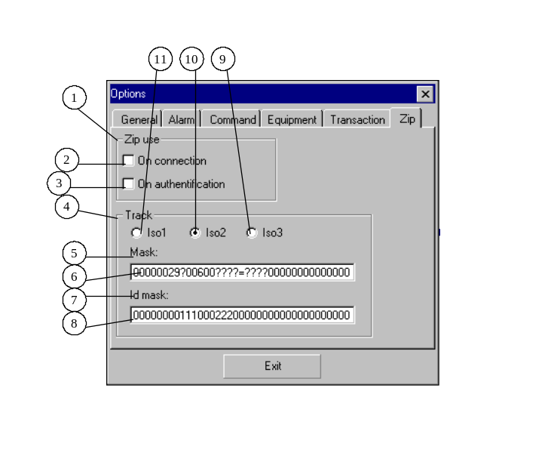
N° | Contrôle | Type
1 | ZipOptions | SSFrame
2 | ZipUseOnConnection | SSCheck
3 | ZipUseOnAuthentication | SSCheck
4 | TrackOptions | SSFrame
5 | TrackMaskLabel | Label
6 | TrackMask | TextBox
7 | TrackIdMaskLabel | Label
8 | TrackIdMask | TextBox
9 | TrackIso3 | SSOption
10 | TrackIso2 | SSOption
11 | TrackIso1 | SSOption

N° | Comment
2 | Use a KDE zip to open a user session
3 | Use a KDE zip to authentify a user
6 | Track mask to confirm the validity of the track
8 | Mask to extract the collector Id from the track
9 | Use the Iso3 track to extract the collector Id
10 | Use the Iso2 track to extract the collector Id
11 | Use the Iso1 track to extract the collector Id

Plaza
Function : main window.

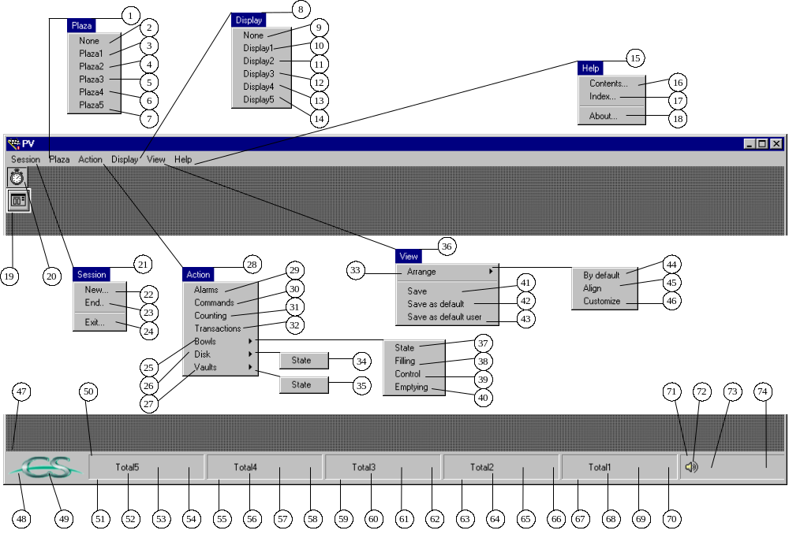

N° | Oject name | Type
0 | Plaza | MdiForm
1 | MenuPlaza | Menu
2 | Plaza0 | Menu
3 | Plaza1 | Menu
4 | Plaza2 | Menu
5 | Plaza3 | Menu
6 | Plaza4 | Menu
7 | Plaza5 | Menu
8 | MenuDisplay | Menu
9 | Display0 | Menu
10 | Display1 | Menu
11 | Display2 | Menu
12 | Display3 | Menu
13 | Display4 | Menu
14 | Display5 | Menu
15 | MenuHelp | Menu
16 | MenuHelpContents | Menu
17 | MenuHelpIndex | Menu
17’ | MenuHelpOptions | Menu
18 | MenuHelpAbout | Menu
19 | CDialog | CommonDialog
20 | Timer | Timer
21 | MenuSession | Menu
22 | MenuSessionNew | Menu
23 | MenuSessionEnd | Menu
24 | MenuSessionExit | Menu
25 | MenuActionBowls | Menu
26 | MenuActionDisk | Menu
27 | MenuActionVaults | Menu
28 | MenuAction | Menu
29 | MenuActionAlarms | Menu
30 | MenuActionCommands | Menu
31 | MenuActionCounting | Menu
32 | MenuActionTransactions | Menu
33 | MenuViewArrange | Menu
34 | MenuActionBowlsState | Menu
35 | MenuActionVaultsState | Menu
36 | MenuView | Menu
37 | MenuActionBowlsState | Menu
38 | MenuActionBowlsFilling | Menu
39 | MenuActionBowlsControl | Menu
40 | MenuActionBowlsEmptying | Menu
41 | MenuViewSave | Menu
42 | MenuViewSaveAsDefault | Menu
43 | MenuViewSaveAsDefaultUser | Menu
44 | MenuViewArrangeByDefault | Menu
45 | MenuViewArrangeAlign | Menu
46 | MenuViewArrangeCustom | Menu
47 | StatusBar | Menu
48 | LogoPanel | SSPanel
49 | Logo | Image
50 | DisplayXPanel | SSPanel
51 | DisplayXTotal5Panel | SSPanel
52 | DisplayXTotal5Title | SSPanel
53 | DisplayXTotal5Shape | Shape
54 | DisplayXTotal5Value | Label
55 | DisplayXTotal4Panel | SSPanel
56 | DisplayXTotal4Title | SSPanel
57 | DisplayXTotal4Shape | Shape
58 | DisplayXTotal4Value | Label
59 | DisplayXTotal3Panel | SSPanel
60 | DisplayXTotal3Title | SSPanel
61 | DisplayXTotal3Shape | Shape
62 | DisplayXTotal3Value | Label
63 | DisplayXTotal2Panel | SSPanel
64 | DisplayXTotal2Title | SSPanel
65 | DisplayXTotal2Shape | Shape
66 | DisplayXTotal2Value | Label
67 | DisplayXTotal1Panel | SSPanel
68 | DisplayXTotal1Title | SSPanel
69 | DisplayXTotal1Shape | Shape
70 | DisplayXTotal1Value | Label
71 | InfoPanel | SSPanel
72 | Speaker | SSRibbon
73 | Server | SSRibbon
74 | DateField | SSPanel

Note : where X = 1 to 5

Prints
Function : manage the printings. This form is never visible.
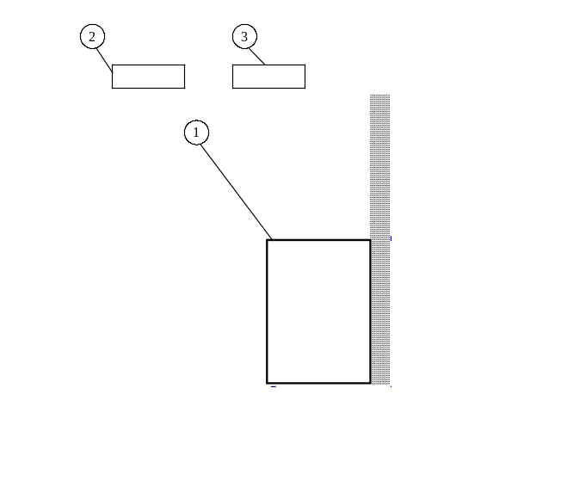
N° | Object name | Type
0 | Prints | Form
1 | DataGrid | MSFlexGrid
2 | Title1 à Title20 | SSPanel
3 | Value1 à Value10 | SSPanel

Tdetails
Function : Display the transaction details for a lane. This form is available through the “Detail” button of the “Transactions” form. “Exit” button to close the form.
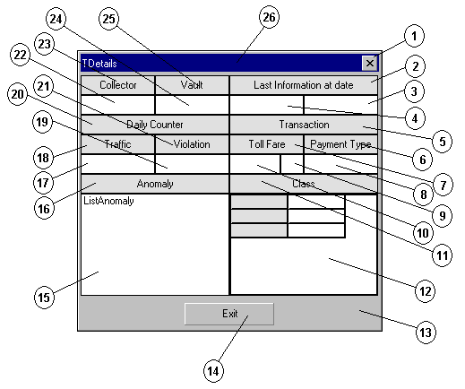
N° | Object name | Type
0 | Tdetails | Form
1 | TitleButton1 | SSRibbon
2 | LastInfoTitle | SSPanel
3 | LastInfoTime | SSPanel
4 | LastInfoDate | SSPanel
5 | TransactionTitle | SSPanel
6 | PaymentTypeTitle | SSPanel
7 | TollFareTitle | SSPanel
8 | PaymentType | SSPanel
9 | Currency | SSPanel
10 | TollFare | SSPanel
11 | ClassTitle | SSPanel
12 | GridClass | MSFlexGrid
13 | Panel | SSPanel
14 | Exit | SSCommand
15 | ListAnomaly | ListView
16 | AnomalyTitle | SSPanel
17 | Traffic | SSPanel
18 | TrafficTitle | SSPanel
19 | Violation | SSPanel
20 | DailyCounterTitle | SSPanel
21 | ViolationTitle | SSPanel
22 | CollectorNumber | SSPanel
23 | CollectorNumberTitle | SSPanel
24 | ActiveVaultNumberTitle | SSPanel
25 | ActiveVaultNumber | SSPanel
26 | Title | SSPanel

Transactions
Function : display the last transactions list. This form is available through the “MenuActionTransactions” menu of the “Plaza” form. “Exit” button to close the form.
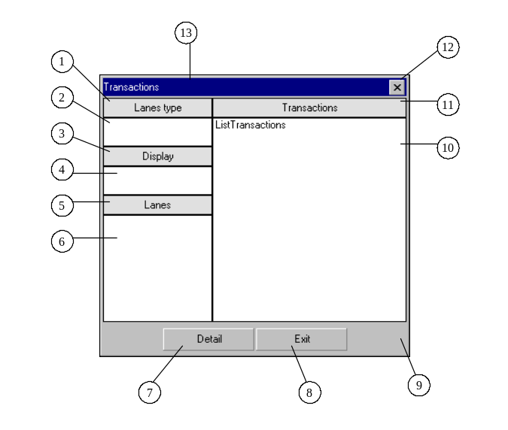
N° | Object name | Type
0 | Transactions | Form
1 | TypeTitle | SSPanel
2 | ListLaneType | ListBox
3 | DisplayTitle | SSPanel
4 | ListLaneDsp | ListBox
5 | LaneTitle | SSPanel
6 | ListLanes | ListBox
7 | Detail | SSCommand
8 | Exit | SSCommand
9 | Panel | SSPanel
10 | ListTransactions | ListView
10 | ListTransactionsPanel | SSPanel
11 | TransactionsTitle | SSPanel
12 | TitleButton1 | SSRibbon
13 | Title | SSPanel

Vaults
Function : display the Vaults state. This form is available through the “MenuActionVaultsState” menu of the “Plaza” form. “Exit” button to close the form.
N° | Object name | Type
0 | Vaults | Form
1 | LaneTitle | SSPanel
2 | ListLanes | ComboBox
3 | VaultTitle | SSPanel
4 | PositionTitle | SSPanel
5 | TypeTitle | SSPanel
6 | FillingTitle | SSPanel
7 | GridState | MsFlexGrid
8 | GridType | MSFlexGrid
9 | TotalRejectedTitle | SSPanel
10 | Detail | SSCommand
11 | Status | SSCommand
12 | Exit | SSCommand
13 | Panel | SSPanel
14 | TotalRejected | SSPanel
15 | GridVault | MSFlexGrid
16 | NumberTitle | SSPanel
17 | StateTitle | SSPanel
18 | RejectedTitle | SSPanel
19 | ActivatedTitle | SSPanel
20 | LastInfoDate | SSPanel
21 | LastInfoTime | SSPanel
22 | LastInfoTitle | SSPanel
23 | TitleButton1 | SSRibbon
24 | Title | SSPanel
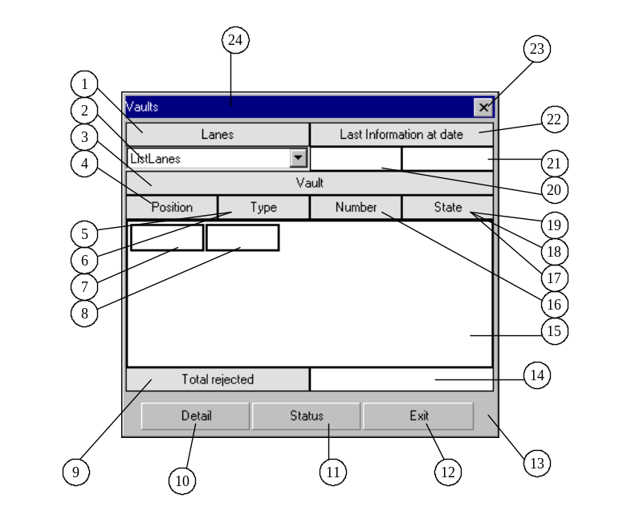

Vdetails
Function : Display the vaults content details. This form is available through the “Detail” button of the “Vaults” form. “Exit” button to close the form.
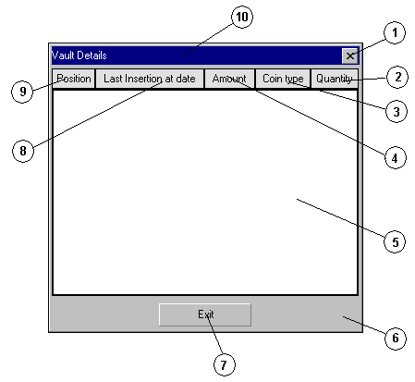
N° | Object name | Type
0 | Vdetails | Form
1 | TitleButton1 | SSRibbon
2 | QuantityTitle | SSPanel
3 | TypeTitle | SSPanel
4 | AmountTitle | SSPanel
5 | GridVaultDetail | MSFlexGrid
6 | Panel | SSPanel
7 | Exit | SSCommand
8 | InsertionTitle | SSPanel
9 | PositionTitle | SSPanel
10 | Title | SSPanel

Zalarms
Function : Display the events list for a lane. This form is displayed when clicking on the “MenuContextAlarms” menu of the “Menu” form. “Exit” button to close the form.

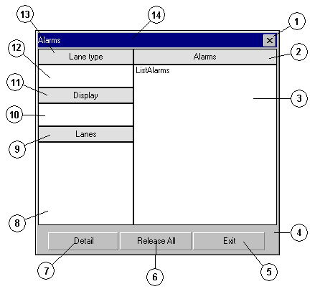
N° | Object name | Type
0 | ZAlarms | Form
1 | TitleButton1 | SSRibbon
2 | AlarmsTitle | SSPanel
3 | ListAlarms | ListView
3 | ListAlarmsPanel | SSPanel
4 | Panel | SSPanel
5 | Exit | SSCommand
6 | Release | SSCommand
7 | Detail | SSCommand
8 | Lane | SSPanel
9 | LaneTitle | SSPanel
10 | Display | SSPanel
11 | DisplayTitle | SSPanel
12 | Type | SSPanel
13 | TypeTitle | SSPanel
14 | Title | SSPanel

Zbowls
Function : Display bowls state for a lane. This form is displayed when clicking on the “MenuContextBowls” menu of the “Menu” form. “Exit” button to close the form.

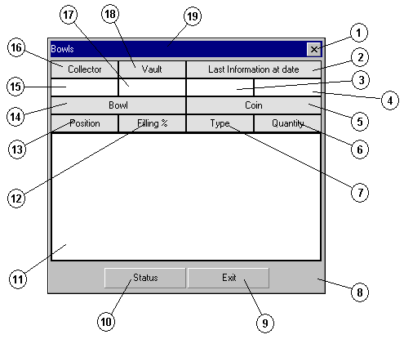
N° | Object name | Type
0 | ZBowls | Form
1 | TitleButton1 | SSRibbon
2 | LastInfoTitle | SSPanel
3 | LastInfoDate | SSPanel
4 | LastInfoTime | SSPanel
5 | CoinTitle | SSPanel
6 | QuantityTitle | SSPanel
7 | TypeTitle | SSPanel
8 | Panel | SSPanel
9 | Exit | SSCommand
10 | Status | SSCommand
11 | GridBowl | MsFlexGrid
12 | FillingTitle | SSPanel
13 | PositionTitle | SSPanel
14 | Bowltitle | SSPanel
15 | CollectorNumber | SSPanel
16 | CollectorNumberTitle | SSPanel
17 | ActiveVaultNumber | SSPanel
18 | ActiveVaultNumberTitle | SSPanel
19 | Title | SSPanel

Zcommands
Function : Display commands list for a lane. This form is displayed when clicking on the “MenuContextCommands” menu of the “Menu” form. “Exit” button to close the form.

N° | Object name | Type
0 | ZCommands | Form
1 | TitleButton1 | SSRibbon
2 | CommandTitle | SSPanel
3 | ListCommands | ListView
3 | ListCommandsPanel | SSPanel
4 | Panel | SSPanel
5 | Exit | SSCommand
6 | Continue | SSCommand
7 | Lane | SSPanel
8 | LaneTitle | SSPanel
9 | Display | SSPanel
10 | DisplayTitle | SSPanel
11 | Type | SSPanel
12 | TypeTitle | SSPanel
13 | Title | SSPanel

Zdisk
Function : Display disk content for a lane. This form is displayed when clicking on the “MenuContextDisk” menu of the “Menu” form. “Exit” button to close the form.

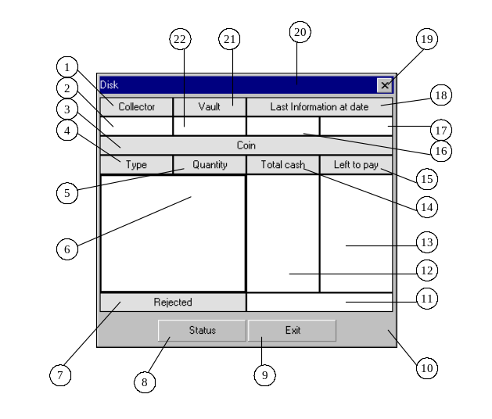
N° | Object name | Type
0 | Disk | Form
1 | CollectorNumberTitle | SSPanel
2 | CollectorNumber | SSpanel
3 | CoinTitle | SSPanel
4 | TypeTitle | SSPanel
5 | QuantityrTitle | SSPanel
6 | GridDisk | MsFlexGrid
7 | RejectedTitle | SSPanel
8 | Status | SSCommand
9 | Exit | SSCommand
10 | Panel | SSPanel
11 | Rejected | SSPanel
12 | TotalCash | SSPanel
13 | LeftToPay | SSPanel
14 | TotalCashTitle | SSPanel
15 | LeftToPayTitle | SSPanel
16 | LastInfoDate | SSPanel
17 | LastInfoTime | SSPanel
18 | LastInfoTitle | SSPanel
19 | TitleButton1 | SSRibbon
20 | Title | SSPanel
21 | ActiveVaultNumberTitle | SSPanel
22 | ActiveVaultNumber | SSPanel

Zip
Function : Manage the KDE Zip. This form is never visible.
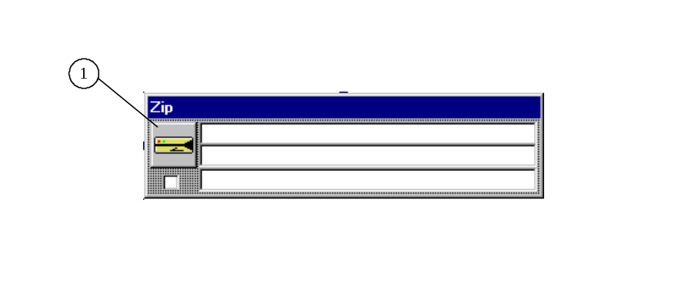

N° | Object name | Type
0 | Zip | Form
1 | ZipKDE | CSRZip

Zlane
Function : Display the lane state details for a lane. This form is displayed when clicking on the “MenuContextLane” menu of the “Menu” form. “Exit” button to close the form.

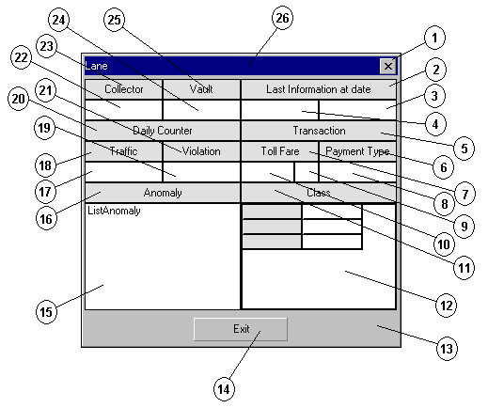
N° | Object name | Type
0 | Zlane | Form
1 | TitleButton1 | SSRibbon
2 | LastInfoTitle | SSPanel
3 | LastInfoTime | SSPanel
4 | LastInfoDate | SSPanel
5 | TransactionTitle | SSPanel
6 | PaymentTypeTitle | SSPanel
7 | TollFareTitle | SSPanel
8 | PaymentType | SSPanel
9 | Currency | SSPanel
10 | TollFare | SSPanel
11 | ClassTitle | SSPanel
12 | GridClass | MSFlexGrid
13 | Panel | SSPanel
14 | Exit | SSCommand
15 | ListAnomaly | ListView
16 | AnomalyTitle | SSPanel
17 | Traffic | SSPanel
18 | TrafficTitle | SSPanel
19 | Violation | SSPanel
20 | DailyCounterTitle | SSPanel
21 | ViolationTitle | SSPanel
22 | CollectorNumber | SSPanel
23 | CollectorNumberTitle | SSPanel
24 | ActiveVaultNumberTitle | SSPanel
25 | ActiveVaultNumber | SSPanel
26 | Title | SSPanel

Ztransactions
Function : Display the last transactions list for a lane. This form is displayed when clicking on the “MenuContextTransactions” menu of the “Menu” form. “Exit” button to close the form.

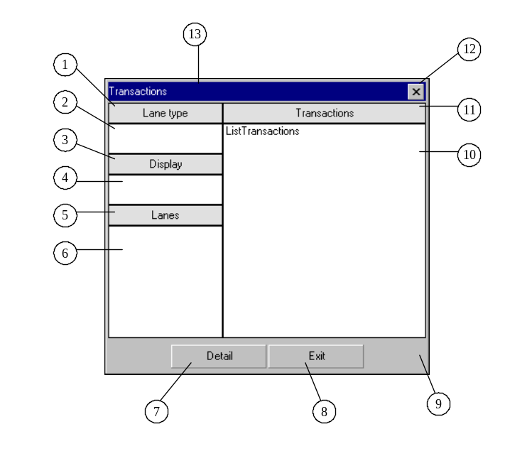
N° | Object name | Type
0 | Transactions | Form
1 | TypeTitle | SSPanel
2 | Type | SSPanel
3 | DisplayTitle | SSPanel
4 | Display | SSPanel
5 | LaneTitle | SSPanel
6 | Lane | SSPanel
7 | Detail | SSCommand
8 | Exit | SSCommand
9 | Panel | SSPanel
10 | ListTransactions | ListView
10 | ListTransactionsPanel | SSPanel
11 | TransactionsTitle | SSPanel
12 | TitleButton1 | SSRibbon
13 | Title | SSPanel

Zvaults
Function : Dsiplay the vaults state for a lane. This form is displayed when clicking on the “MenuContextVaults” menu of the “Menu” form. “Exit” button to close the form.

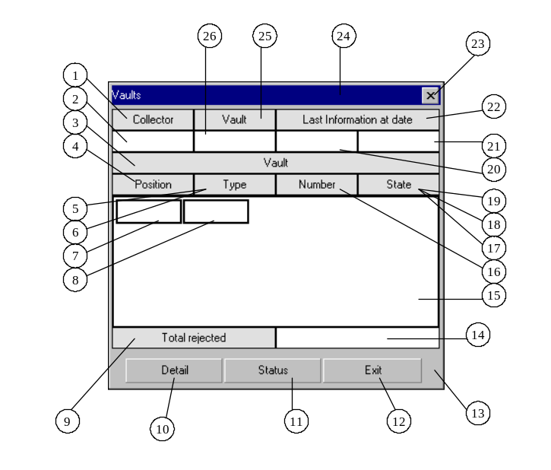
N° | Object name | Type
0 | Vaults | Form
1 | CollectorNumberTitle | SSPanel
2 | CollectorNumber | SSpanel
3 | VaultTitle | SSPanel
4 | PositionTitle | SSPanel
5 | TypeTitle | SSPanel
6 | FillingTitle | SSPanel
7 | GridState | MsFlexGrid
8 | GridType | MSFlexGrid
9 | TotalRejectedTitle | SSPanel
10 | Detail | SSCommand
11 | Status | SSCommand
12 | Exit | SSCommand
13 | Panel | SSPanel
14 | TotalRejected | SSPanel
15 | GridVault | MSFlexGrid
16 | NumberTitle | SSPanel
17 | StateTitle | SSPanel
18 | RejectedTitle | SSPanel
19 | LastInfoDate | SSPanel
20 | LastInfoTime | SSPanel
21 | LastInfoTitle | SSPanel
22 | TitleButton1 | SSRibbon
23 | Title | SSPanel
24 | ActiveVaultNumberTitle | SSPanel
25 | ActiveVaultNumber | SSPanel

SETTINGS FILEs
The settings of the client application are located in the following text files :
- Command.txt (lane commands description)
- Dico.txt (inventory of the application labels)
- Display1024x768.txt (displays properties for a resolution of 1024x768)
- Display800x600.txt (displays properties for a resolution of 800x600)
- Equipment.txt (lane equipments description)
- Error.txt (define the path for the error file)
- Function.txt (PV functions description)
- Plaza.txt (Remote plaza properties)
- Position.txt (Position of the Lane window in the main window)
- Resource.txt (Properties of the application layout)
- Type.txt (Description of the type of lanes)
- User.txt (Default user)
- Zone1024x768.txt (Definition of the different zone for a resolution of 1024x768)
- Zone800x600.txt (Definition of the different zone for a resolution of 800x600)
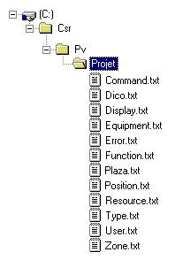
Note : In these files, all the lines preceded by ‘!’ are comments lines.

RESOURCE
Resource.txt is a text file which is used to set the properties of the application objects in order to define its layout.
Syntax to set a property to a form :
Form.Property Value
Syntax to set a property to a control :
Form.Control.Property Value

Example :
About.Exit.Caption Exit
The caption of the command button of the window About is « Exit »

To define a value for a property, it’s possible to use a keyword (between # characters). The corresponding value of this keyword is defined in the Dico.txt file.
Form.Control.Property #KEYWORD#

DICO
Dico.txt is a text file which is used to set to each keyword its corresponding value

Syntax to set a value to a keyword :
#KEYWORD# Value

COMMAND
Command.txt is a text file which is used to describe all the commands that can be sent to the lanes.
Syntax to describe a command:
[CommandId] (T_COMMAND : ID_COMMAND)
Cdetails.Control.Property Value

The command message sent to the lanes is built according to the visible controls of the Cdetails window (by default, all the controls of this window are hidden).
The property “Tag” of each control sets the position of the information in the message to be built.
The “ID” and “CD” controls sets the ID and CD of the command (even if they are hidden, they will be taken into account for the building of the message).
The “Type” control sets the type of the command in the message. If the “Type” is empty, the size of the command will be ignored in the message to be built
Examples :
- Message with a type not empty : User instruction message ( T_COMMAND : ID_COMMAND = 1)
- Command.txt:

[01]
CDetails.Id.Text 120
CDetails.Cd.Text 072
CDetails.CommandType.Text 01
CDetails.Label.Visible True
CDetails.Label. Caption #USER_INSTRUCTIONS# (Dico.txt)

CDetails.TextTitle.Caption #INSTRUCTIONS# (Dico.txt)
Cdetails.TextTitle.Top 0
Cdetails.TextTitle.Left 0
Cdetails.TextTitle.Visible True
Cdetails.ShortText.Left 0
Cdetails.ShortText.Top 400
Cdetails.ShortText.Width 4935
Cdetails.ShortText.MaxLength 50
Cdetails.ShortText.Tag 0
Cdetails.ShortText.Visible True

- Window displayed :

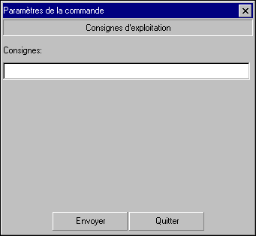

- Message sent to the lane:
Id 120
Cd 072
Plaza Number (filled by the server)
Lane Number (filled by the server)
Mnumber (filled by the server)
Date/Time (filled by the server)
Toll Collector Id (filled by the server)
Active Vault id (filled by the server)
Command Type 01
Information Length 007
Information Hello

- Message with empty type : Backup request ( T_COMMAND : ID_COMMAND = 2)
- Command.txt

[02]
CDetails.Id.Text 120
CDetails.Cd.Text 073
CDetails.Label.Visible True
CDetails.Label.Caption #BACKUP_REQUEST# (Dico.txt)

CDetails.Title1.Caption #START_DATE# (Dico.txt)
CDetails.Title1.Width 1200
CDetails.Title1.Top 0
CDetails.Title1.Left 0
CDetails.Title1.Visible True
CDetails.Date1.Top 0
CDetails.Date1.Left 1300
CDetails.Date1.Width 1300
CDetails.Date1.Tag 0
CDetails.Date1.Visible True
CDetails.Date1.CustomFormat dd/MM/yyyy

CDetails.Title3.Caption #END_DATE#
CDetails.Title3.Width 1200
CDetails.Title3.Top 400
CDetails.Title3.Left 0
CDetails.Title3.Visible True
CDetails.Date2.Top 400
CDetails.Date2.Left 1300
CDetails.Date2.Width 1300
CDetails.Date2.Tag 1
CDetails.Date2.Visible True
CDetails.Date2.CustomFormat dd/MM/yyyy

- Window displayed :
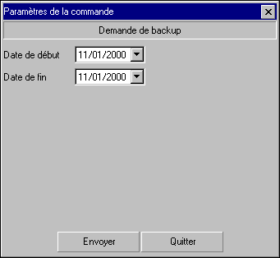

- Message sent to the lane:
Id 120
Cd 073
Plaza Number (filled by the server)
Lane Number (filled by the server)
Mnumber (filled by the server)
Date/Time (filled by the server)
Toll Collector Id (filled by the server)
Active Vault id (filled by the server)
Begin Date 20001101000000
End Date 20001101235959

Note : For commands with no parameter, set the NoDisplay control value to true.
Cdetails.Nodisplay.Value True

DISPLAY
DisplayXXXX.txt is a text file which is used to describe the different plaza or group of lanes.

Syntax of a display:
[DisplayId] (T_LANE_ATTACH_TO : ID_LANE_GROUP)
Label Value (Label displayed in the “Display” menu of the main window )
Picture Keyword (Keyword of the picture in the “Plaza” imagelist of the “album” window)

Example : two displays : Gare1 and Gare2
- DisplayXXX.txt
[01]
Label Gare1
Picture G1

[02]
Label Gare2
Picture G2
- Menu displayed:
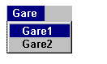
- In resource.txt:
Album.Plaza.Image(G1) c:\…\…\Plaza1.bmp
Album.Plaza.Image(G2) c:\…\…\Plaza2.bmp

Note : by selecting Gare1, plaza1 picture becomes the background picture of the main window.

ZONE
A zone describes a screen area. The Lanes which belong to the zone cannot move outside this area.
ZoneXXXX.txt is a text file which is used to define these area.

Syntax of a zone:
[ZoneId] (T_LANE_ATTACH_TO : RTO_ZONE)
Name Value (Not used)
MinTop Value (superior limit of the area, 0 if missing)
MinLeft Value (left limit of the area, 0 if missing)
MaxRight Value (right limit of the area, screen widh if missing)
MaxBottom Value (bottom limit of the area, screen height if missing)

Example : two zones : Zone1 and Zone2
[01]
Name Zone1
MaxBottom 4800

[02]
Name Zone2
MinTop 5480
MaxBottom 10280

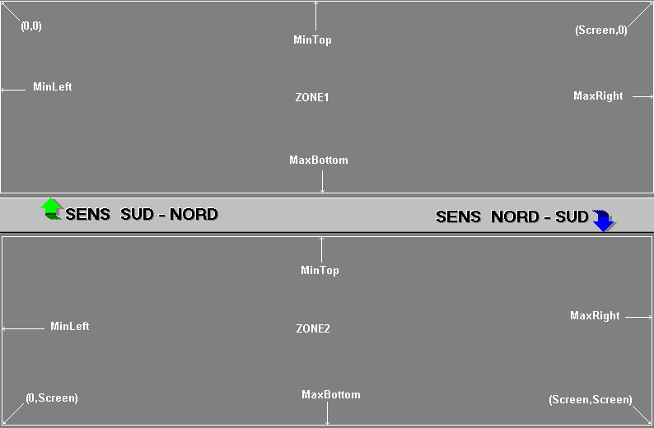

TYPE
Type.txt is a text file which is used to define the different lane types and the pictures to display according their states and their open modes.
The state of a lane is given by the state of an event which is defined in GEN_DEF. Idem for the mode.
Note :
If Shift state = 0 then state = unknown else Shift state = shift event state + 1
If Open Mode = 0 then state = unknown else Open mode = open event state + 1
Keyword = Keyword in the “Lane” imagelist of the “album” window
The picture is displayed in the Lane window (LaneTypeImage control)
Syntax of a type of lane:
[1]
Name Value (name of the type of lane)
Label (Label of the type of lane displayed in the windows Alarms, commands, …)

Shift0Mode0 Keyword (picture when the shift and the mode are unknown)
Shift1Mode0 Keyword
…
ShiftXMode0 Keyword
…
ShiftXModeX Keyword

EQUIPMENT
Equipment.txt is a text file which is used to define the different equipments and the pictures to display according their states.
The state of an equipment is given by the state of the event which is defined in T_LANE_EQUIPMENT_TYPE.

- Some equipments are already defined :
- CANOPY :
Update the “CanopyImage” control of the lane window
Syntax :
[01]
Name CANOPY
CANOPY(#) Keyword
CANOPY(0) Keyword
CANOPY(1) Keyword
Visible False

- TOBLERONE :
Update the “TobleroneImage” control of the lane window
[02]
Name TOBLERONE
TOBLERONE(#) Keyword
TOBLERONE (0) Keyword
TOBLERONE (1) Keyword
Visible False

- CLASSBIS :
Update the “ClassBis” control of the lane window
[03]
Name CLASSBIS
Visible False

- CLASSTER :
Update the “ClassTer” control of the lane window
[04]
Name CLASSTER
Visible False

- BOWL :
Activate the “bowls” menu item of the menu window
[04]
Name BOWL
Visible False

- DISK :
Activate the “Disk” menu item of the menu window
[05]
Name DISK
Visible False

- VAULT :
Activate the “vaults” menu item of the menu window
[06]
Name VAULT
Visible False

- Syntax for the other equipments:
The picture will be displayed in the EquipmentGrid control of the lane window (with a max of 4 equipment in this grid)

[EquipmentId]
Name EqName
EqName(#) Keyword
EqName(0) Keyword
EqName(1) Keyword
…
Visible True

ERROR
Equipment.txt is a text file which is used to define the path for the error file (debug).
Syntax :
Name Path

FUNCTION
Function.txt is a text file which is used to set all the controls referring to a functionality.
Syntax :
[FunctionId]
Form.Control
Form.Control
….
Example :
[03]
Plaza.MenuSessionExit

If the function id 03 is password protected in T_PROFILE_USE_MENU, it will protect the function called by the MenuSessionExit control of the Plaza window.

PLAZA
Plaza.txt is a text file which is used to sets the path of the remote plaza configurations.
The defined remote plaza are displayed in the menu plaza of the plaza window.
The effect of this menu is to close the current application and restart it with a different configuration (the configuration of the remote plaza).
Syntax :
[PlazaId]
Name Value
Path Value
Example :
[01]
Name plaza2
Path \\machine1\plaza2

PRINT
Print.txt is a text file which is used to describe the print layout for the windows which have a print functionality (Counting, Bprinting, Limits)

Syntax :
[Form Name] (Counting, Bprinting, Limits)
Prints.Control.Property Value
….

Note:
In the Prints form, the use of Title1 to Title20 controls is free.
The Value1 control is dedicated to the print date, the Value2 control to the plaza name, the Value3 and Value4 controls to the Start date and End date for the Limits form.
The DataGrid control is dedicated to the result data.

USER
User.txt is a text file which is used to set the identification of the user who will be logged by default at each launching of the application.

Syntax:
Matricule Value (user reference number)
Password Value (user password, encrypted or not)

SPECIFIC SETTINGS

Event Icons
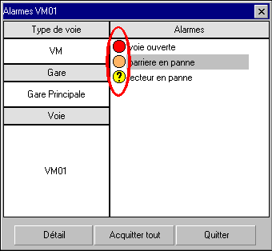

Syntax in the Resource.txt file :
Album.Alarms.Image(LevelXAckY) c:\…\…\image.bmp
With : X = event level
Y = event release state ( 0 released, 1 to release, 2 cannot be released)

Transaction anomaly Icons
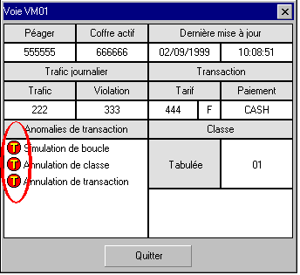
Syntax in the Resource.txt file :
Album.Anomaly.Image(AXX) c:\…\…\image.bmp
With XX = Anomaly Id ( 2 digits)

Transaction Icons
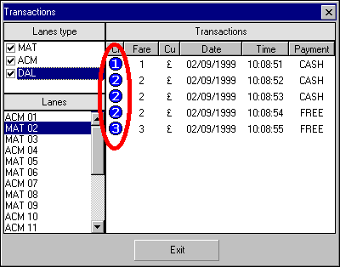

Syntax in the Resource.txt file :
Album.Transactions.Image(CLASSX) c:\…\…\Image.bmp
With X = Class number

Events level colour
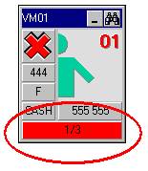
Syntax in the Resource.txt file :
Event.None.BackColor Colour (example : &H0080FF80&)
Event.LevelX.BackColor Colour
With X = event level

Message Box Text

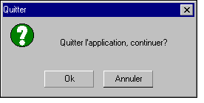

Syntax in the Resource.txt file :
MsgBox.XXXX.Text Caption
With XXXX = MsgSave
MsgExit
MsgEnd
MsgRefused
MsgFull
MsgInterrupted
MsgNoReponse
MsgReleaseAll
MsgReleaseOne
MsgSend
MsgLostConnection
MsgDate

